BCSE497J - Project-I

Context-Aware AI-Based Detection of Multi-Stage Web Injection Attacks Using Sequential HTTP Request Analysis

23BCI0056 | KOUSTAV MITRA
23BCI0060 | M. SRIKAR BHARADWAJ
23BCE2262 | R. PHANINDRA SANJAY

Under the Supervision of

Dr. Ganesh Shamrao Khekare
Assistant Professor Sr. Grade 2
School of Computer Science and Engineering (SCOPE)

B.Tech.
in
Computer Science and Engineering
(Specialization Information Security)

School of Computer Science and Engineering



September 2026

ABSTRACT

Web application attacks often manifest as a sequence of orchestrated activities instead of isolated, single-use malicious requests. This operational reality necessitates intrusion detection systems to shift away from stateless, request-centric inspection toward causal, session-level sequential analysis. This work presents a context-aware artificial intelligence framework designed to detect, track, and forecast multi-stage web injection attacks across sequential HTTP transactions. The framework defines a comprehensive five-stage attack taxonomy consisting of Normal, Reconnaissance, Fuzzing, Injection, and Exploitation stages, enabling defenders to track individual HTTP transactions and establish their exact placement within an active attack campaign.

An empirical experimental dataset was constructed using a locally containerized, network-isolated deployment of the OWASP Juice Shop vulnerable web application, intercepted via mitmproxy and Burp Suite across 62 capture files (comprising 2,878 raw HTTP requests) alongside approximately 1,200 live-response requests in the training split. To evaluate non-trivial sequential dynamics without synthetic shortcuts, contiguous request blocks (3 to 16 requests) were composed into an extensive multi-stage corpus of 2,100 sessions containing 72,269 total request instances, partitioned using a file-disjoint protocol where source capture files and raw request blocks are strictly split-disjoint across training, validation, and testing partitions. To enforce strict operational causality without future lookahead bias, the system employs a 31-dimensional causal feature extraction framework incorporating request morphology, payload regex signatures, endpoint sensitivity classes, response status metrics, and decaying session-context indicators. Current-stage detection is executed via a responsive causal ensemble combining a per-request gradient boosted decision tree (XGBoost) and a seed-averaged Long Short-Term Memory (LSTM) recurrent neural network, fused via equal-weight probability blending (alpha = 0.50) and calibrated through temperature scaling (T = 0.916). A causal Hidden Markov Model (HMM) forward filter tracks Bayesian state belief, enabling proactive next-distinct-stage intent forecasting and providing an optional lower-false-positive operating mode.

The proposed system was empirically evaluated on a held-out, file-disjoint test corpus consisting of 300 sessions and 10,174 HTTP requests (derived from 12 held-out capture files). The deployed causal ensemble achieves an overall accuracy of 54.31% and a Macro-F1 score of 0.5060, outperforming parameter-free lookup heuristics by +24.36 percentage points. Transition edge accuracy reaches 0.4156, reflecting the operational trade-off between rapid boundary adaptation and temporal smoothing. Sequential recurrent modeling constrains the per-request benign false-positive rate to 14.00% (and 10.97% in HMM forward-filtering mode), achieving a 41.4% reduction in false alarms compared to standalone XGBoost (23.90%), though per-request false alarms remain an operational challenge in high-throughput environments. At the session campaign level, the detector catches 86.09% of all attack sessions (74.29% to 91.45% across individual attack stages, identifying 91.45% of critical exploitation sessions) with a 35.29% false alarm rate on benign sessions (down from 52.94% for standalone XGBoost) and a median detection latency of 1 request. Furthermore, Bayesian next-distinct-stage intent forecasting achieves 33.69% Top-1 and 55.17% Top-2 accuracy at real phase transitions, providing early-warning indication while sustaining an end-to-end algorithmic inference latency averaging 0.18 ms per request.

Keywords — Multi-Stage Web Attacks, Web Injection Detection, Sequential HTTP Analysis, Long Short-Term Memory (LSTM), Hidden Markov Model (HMM), Ensemble Learning, Context-Aware Cybersecurity.

TABLE OF CONTENTS
Sl.No | Contents | Page No.
 | Abstract
1. | INTRODUCTION | 6
 | 1.1 Background | 6
 | 1.2 Motivation | 7
 | 1.3 Scope of the Project | 7
2. | PROJECT DESCRIPTION AND GOALS | 9
 | 2.1 Literature Review | 9
 | 2.2 Research Gap | 10
 | 2.3 Objectives | 10
 | 2.4 Problem Statement | 11
 | 2.5 Project Plan | 12
3. | TECHNICAL SPECIFICATION | 13
 | 3.1 Requirements | 13
 | 3.1.1 Functional Requirements | 13
 | 3.1.2 Non-Functional Requirements | 13
 | 3.2 Feasibility Study | 14
 | 3.2.1 Technical Feasibility | 14
 | 3.2.2 Economic Feasibility | 15
 | 3.2.3 Social and Ethical Feasibility | 15
 | 3.3 System Specification | 16
 | 3.3.1 Hardware Specification | 16
 | 3.3.2 Software Specification | 16
4. | DESIGN APPROACH AND DETAILS | 17
 | 4.1 System Architecture | 17
 | 4.2 Design | 17
 | 4.2.1 Data Flow Diagram | 18
 | 4.2.2 Use Case Diagram | 19
 | 4.2.3 Class Diagram | 20
 | 4.2.4 Sequence Diagram | 21
5. | IMPLEMENTATION AND EXPERIMENTAL METHODOLOGY | 22
 | 5.1 Implementation Environment and Specifications | 22
 | 5.2 Five-Stage Attack Taxonomy and Operational Scope | 22
 | 5.3 Dataset Construction and In-House Testbed | 23
 | 5.4 The 31 Causal Feature Engineering Framework | 26
 | 5.5 Machine Learning Baseline Models | 29
 | 5.6 Hidden Markov Model (HMM) Transition Dynamics | 30
 | 5.7 Causal Ensemble Architecture and Decision Logic | 30
 | 5.8 Evaluation Metrics | 31
 | 5.9 Experimental Setup and Reproducibility | 32
6. | RESULTS AND EVALUATION | 33
 | 6.1 Benchmark Comparison on Held-Out Test Set | 33
 | 6.2 Per-Class Performance and Confusion Matrix Analysis | 34
 | 6.3 Transition Edge Accuracy and Sequential Consistency | 36
 | 6.4 False-Positive Rate Reduction via Temporal Context | 36
 | 6.5 Session-Level Attack Campaign Detection | 36
 | 6.6 Early Detection Latency & Defensive Lead Time | 37
 | 6.7 Next-Stage Attack Intent Forecasting | 38
 | 6.8 Real-Time Streaming and Inference Latency | 39
7. | DISCUSSION | 41
 | 7.1 The Value of Context in Web Application Security | 41
 | 7.2 Error Analysis: The Fuzzing-Injection Boundary | 41
 | 7.3 Operational Feasibility in Security Operations Centers | 42
 | 7.4 Latency vs. Accuracy Trade-Off | 42
 | 7.5 Partitioning Protocol and Data Disjunction Analysis | 43
 | 7.6 Threats to Validity and Limitations | 43
8. | CONCLUSION AND FUTURE WORK | 45
 | 8.1 Summary of Contributions | 45
 | 8.2 Future Research Directions | 45
9. | REFERENCES | 47

1. INTRODUCTION

1.1 Background
The accelerated migration of enterprise services to web and cloud architectures has rendered web applications the primary attack surface for modern cyber adversaries. Modern web applications process sensitive transactions, interact with backend relational and NoSQL databases via RESTful APIs, and expose rich client-side single-page interfaces. Among all web vulnerability classes, injection attacks—predominantly Structured Query Language (SQL) injection and its variants—consistently rank among the most devastating threats cataloged in the OWASP Top 10 (A03:2021 - Injection). A successful injection exploit can result in complete database compromise, unauthorized data exfiltration, administrative privilege escalation, and remote code execution on backend host systems.

Historically, intrusion detection systems (IDS) operated at the network packet layer (Layers 3 and 4), inspecting IP addresses, TCP sequence flags, and flow volume metrics. While effective against volumetric denial-of-service and network-layer port scans, packet-level inspection is inherently blind to application-layer (Layer 7) injection attacks encapsulated within encrypted TLS/HTTPS sessions. Detecting semantic web attacks requires parsing HTTP URI paths, query strings, multipart form bodies, and JSON payloads. Crucially, sophisticated adversaries do not launch exploit payloads blindly; they execute systematic, multi-step campaigns that unfold over chronological user sessions. Capturing this behavior requires moving beyond isolated packet analysis to stateful, session-aware inspection.

An alternative approach to network-level anomaly detection is to conceptualise HTTP traffic within the context of a user’s session. In this case, a single HTTP request would have limited information about an ongoing attack, but the analysis of a series of requests in chronological order could reveal the attack’s progression. An attack session against a web application could be split into distinct phases, including Normal (benign) user behaviour, Reconnaissance, Fuzzing, Injection, and Exploitation. The analysis of requests within an ongoing HTTP session could be used to train an intrusion detection classifier to identify the current stage of an attack and predict future developments. Notably, such a system would be able to differentiate between suspicious single requests and a series of requests that comprise an attack session. The application of such a system would enhance the detection of multi-stage web injection attacks, minimise false positives and provide additional context about the attacker’s intentions and behaviours.

The rapid development of artificial intelligence and sequential analysis models over the past decade also supports the application of this attack detection concept. In this project, an LSTM neural network can be used to process sequential HTTP requests, XGBoost gradient boosting could be applied to analyse the features of individual requests and sessions, and a Hidden Markov Model could predict the next stage of an ongoing attack. Overall, the research project will explore the application of a new causal intrusion detection framework that employs multiple models to analyse HTTP sessions and predict the stages of an ongoing attack.

1.2 Motivation
The primary motivation for this research stems from the fundamental operational failure of stateless Web Application Firewalls (WAFs). Conventional WAFs and signature-matching appliances evaluate each HTTP transaction in absolute isolation, discarding state immediately after processing. This stateless architecture exhibits two fatal limitations in enterprise environments. First, it induces overwhelming false-positive rates on complex legitimate traffic: legitimate search queries containing special characters, nested JSON objects, or base64 authentication tokens frequently trigger rigid regex patterns, generating thousands of spurious alerts that desensitize security operations center (SOC) analysts.

Second, stateless inspection is easily bypassed by sophisticated adversaries who distribute attack activities across an extended temporal session. An adversary initially navigates normally, probes endpoints to map input fields, executes boundary fuzzing to identify database error responses, verifies syntax with subtle boolean probes, and only then submits the final exploitation payload. Under stateless inspection, early reconnaissance and fuzzing probes appear as benign misconfigurations or routine application exploration. Only by tracking the decaying temporal context and sequential transition dynamics across an entire session can a security system correlate these interrelated steps, suppress false positives, and provide early warning before database compromise occurs.

For these reasons, this project develops a novel context-aware framework for session-based web intrusion detection. The five-stage classification of Normal, Reconnaissance, Fuzzing, Injection, and Exploitation models the chronological progression of an attack across consecutive HTTP transactions. A key motivation for this approach is transitioning from reactive signature matching to proactive progression tracking. By tracking session progression through these stages, defenders obtain actionable early warning to intervene before exploitation or data exfiltration occurs. The system integrates Long Short-Term Memory recurrent neural networks, Extreme Gradient Boosted (XGBoost) decision trees, and Hidden Markov Models to track session trajectories, classify requests under strict causality, and forecast impending transitions.

1.3 Scope of the Project
The project aims to develop a context-aware intrusion detection system that can detect multi-stage web injection attacks by analyzing the sequence of HTTP requests. The traffic data was captured using Burp Suite from an experimental environment that used OWASP Juice Shop. The exported data represents HTTP requests and responses grouped into sessions that enable reconstructing the chronological order of requests.

The scope of this project encompasses the design, implementation, and empirical evaluation of a context-aware machine learning framework for detecting and forecasting multi-stage web injection attacks across sequential HTTP request streams. The system models application-layer traffic according to a five-stage progression: Normal, Reconnaissance, Fuzzing, Injection, and Exploitation. Evaluation is conducted on a dedicated in-house corpus of 2,100 sessions and 72,269 request instances generated using the OWASP Juice Shop web application, strictly partitioned under a file-disjoint protocol where source capture files and request blocks are partitioned prior to session composition. The framework is engineered strictly under operational temporal causality: at any request step t, features and predictions depend exclusively on requests <= t, ensuring direct deployability in real-time reverse proxies. The scope focuses specifically on Layer-7 web injection campaigns and does not address generic network DDoS or host-level kernel rootkits.

In general, the system was developed to perform attack detection and session tracking while predicting attack stages. The project’s evaluation was performed on a session-based, leak-free corpus of data that uses a range of features for attack detection. The experiments and results analysis focused on the system’s ability in detecting the current attack stage, transition between attack stages, false positives, detection performance at the session level, and next-stage prediction. However, the project is not a generic intrusion detection system that could be applied to any cybersecurity task or use case. The system is specifically focused on the concept of attack stages and uses particular features relevant to web application attacks.
2. PROJECT DESCRIPTION AND GOALS
2.1 Literature Review
The intrusion detection field has evolved from deterministic rule-based systems toward statistical machine learning and deep neural network architectures. Wisanwanichthan and Thammawichai [1] proposed a two-layer hybrid architecture combining Naive Bayes and Support Vector Machines (SVM) with Principal Component Analysis, achieving 95.07% accuracy on the NSL-KDD benchmark. Tartakovsky et al. [2] developed adaptive sequential change-point detection algorithms using cumulative sum (CUSUM) statistics, capturing rapid network anomalies but exhibiting severe performance degradation on low-frequency, semantic attacks. Chaabouni et al. [11] surveyed machine learning and deep learning techniques for IoT security, highlighting the trade-off between model expressiveness and inference latency. Karatas et al. [28] conducted cross-evaluation of machine learning NIDS, proving that models trained on specific network topologies suffer from severe generalization drops when exposed to foreign traffic distributions. Salih et al. [30] comprehensively reviewed machine learning and deep learning paradigms across enterprise cybersecurity, confirming that while supervised classifiers excel at static pattern matching, they fail to capture multi-stage behavioral progressions.
Recognizing the limitations of stateless inspection, foundational web security research explored anomaly-based HTTP analysis. Kruegel and Vigna [3] pioneered multi-model anomaly detection for web attacks, profiling URI length, character distribution, and parameter structural tokens. Robertson et al. [4] extended this approach by using generalization and anomaly characterization to detect and cluster novel web-based attacks. Pathan [9] formulated an agent-based, self-adaptable vulnerability assessment framework that continuously evaluates contextual application feedback. In the domain of web application firewalls, Betarte et al. [7] provided a systematic review of machine learning techniques for WAFs, highlighting the operational challenge of high false-positive rates under dynamic web traffic. While these approaches confirmed that feature contextualization improves detection fidelity, their inspection remained predominantly request-centric, treating each transaction in isolation without modeling chronological session trajectories.
Sequential and recurrent architectures have demonstrated high efficacy in modeling temporal sequences. Bertoli et al. [6] proposed the AB-TRAP analytics framework, emphasizing the necessity of continuously updated sequential datasets for deep learning evaluation. Dou et al. [8] applied similarity metric learning to event-triggered traffic time series. In the web security domain, Jagat et al. [20] proposed a Variational LSTM Autoencoder deviation network to detect web attacks from HTTP weblogs, while Tang et al. [23] implemented LSTM sequence models for SQL injection detection. Furthermore, Guo et al. [10] established that modern deep neural networks tend to output uncalibrated, overconfident probabilities and demonstrated that post-hoc Temperature Scaling effectively restores probabilistic calibration without altering model accuracy. In multi-stage threat analysis, Hutchins et al. [11] formalized the Cyber Kill Chain, modeling attacks as a structured sequence of operational phases, while Strom et al. [18] systematized adversary techniques in the MITRE ATT&CK Matrix for Enterprise. These works confirmed that sequential pattern recognition and calibrated state modeling are essential for tracking progressive multi-stage attack chains.
Modeling the progression of multi-stage cyber campaigns has been studied using probabilistic graphical models. Shawly et al. [5] developed an HMM-based architecture in IEEE TDSC to detect and track interleaved multi-stage network attacks, representing discrete attack steps as hidden states. Radoglou-Grammatikis et al. [12] analyzed low-frequency, multi-stage attacks in industrial networks, showing that slow probing often escapes traditional threshold detectors. Yoon and Kang [13] applied Latent Dirichlet Allocation (LDA) to group multi-stage threat events into latent attack topics. Maimo et al. [14] extracted threat behaviors via unsupervised clustering of multi-stage network flows. Cao et al. [19] investigated sequential attack detection in recommender systems, modeling malicious profile injections as sequential markovian deviations. Chadza et al. [22] proposed an HMM transfer learning framework for sequential network attack detection and next-stage intent prediction. These studies confirmed that Markov models capture state progression effectively; however, they operated primarily on network-layer alert sequences rather than application-layer HTTP session streams.
A critical limitation of intrusion detection research lies in benchmark dataset design. Widely cited web datasets—such as the CSIC 2010 HTTP Dataset (Torrano-Giménez and Álvarez [15]) and the ECML/PKDD 2007 Discovery Challenge—contain thousands of tagged HTTP requests but entirely lack multi-request session attack progressions, rendering them unsuitable for sequential modeling. General-purpose intrusion datasets such as CICIDS-2017 (benchmarked by Maseer et al. [21] and analyzed with Information Gain feature selection by Panigrahi and Borah [24]) evaluate isolated packet captures. In the domain of SQL injection defense, Floris et al. [25] proposed ModSec-AdvLearn in IEEE TIFS to counter adversarial SQL injections through robust machine learning; Lakhina et al. [26] analyzed traffic anomaly detection via feature distributions; Sarhan et al. [27] applied Explainable AI (XAI) to interpret feature importance in network classifiers; and Bharadwaj and Khekare [29] analyzed detection gaps and defense mechanisms in web injection vectors. Furthermore, the proposed five-stage operational taxonomy translates established tactics from ATT&CK [18] and the Kill Chain [11]—including Active Scanning (T1595), Exploit Public-Facing Application (T1190), and Credential Access (T1212)—into observable application-layer session states. Whereas foundational alert correlation research (e.g., Valeur et al. [16], IEEE TDSC 2004; Ning et al. [17], ACM TISSEC 2004) focused on complex post-hoc graph reconstruction of disconnected network alarms, the proposed approach provides lightweight, online Bayesian HMM forward filtering that executes in line-rate without alert flooding.
2.2 Research Gap
Although state-of-the-art intrusion detection research has applied diverse machine learning and deep learning algorithms, existing solutions overwhelmingly evaluate individual, isolated HTTP transactions. Previous web security studies have focused either on post-hoc parsing of web server access logs (such as static Apache or Nginx combined log formats) or on network-layer packet captures. Access logs record only URI paths and response status codes, discarding request POST bodies, headers, and payload semantics, whereas network packet captures cannot inspect TLS-encrypted application content. Furthermore, standard benchmarks (CSIC 2010, NSL-KDD, CICIDS2017) fail to capture multi-stage web injection attack chains where benign navigation, parameter exploration, boundary fuzzing, syntax verification, and exploitation occur chronologically within the same user session.
Consequently, there is a fundamental research gap in context-aware, sequential detection for multi-stage web injection attacks. Current defenses lack the capability to correlate application-layer HTTP payload features with decaying session context under strict operational causality (guaranteeing zero future lookahead). This research addresses this gap by designing, implementing, and empirically evaluating a hybrid causal framework that tracks attack progression in real-time, suppresses benign false positives through session memory, and forecasts impending attacker intent before critical exploitation occurs.

2.3 Objectives
The primary objective of this project was to develop, implement, and empirically validate a context-aware AI detection framework for multi-stage web injection attacks across sequential HTTP transactions. The specific technical objectives accomplished in this study are:
1. Formulated an operational five-stage attack taxonomy (Normal, Reconnaissance, Fuzzing, Injection, Exploitation) and engineered a 31-dimensional causal feature extraction engine that combines per-request syntactic morphology, regex signatures, endpoint sensitivity, and decaying session-context indicators, guaranteeing strict zero future lookahead.
2. Curated an authentic experimental corpus of 2,100 sessions totaling 72,269 HTTP request instances from real Burp Suite captures on a locally containerized OWASP Juice Shop testbed, enforcing whole-file-level partitioning prior to block composition to establish a file-disjoint evaluation protocol.
3. Constructed and deployed a multi-model causal ensemble architecture fusing a seed-averaged Long Short-Term Memory (LSTM) recurrent neural network with an XGBoost tree classifier via calibrated temperature scaling (T = 0.916) for responsive current-stage tracking, coupled with a Hidden Markov Model (HMM) forward filter for Bayesian state estimation and next-distinct-stage intent forecasting.
4. Conducted comprehensive empirical evaluation on a held-out file-disjoint test split of 10,174 requests, quantifying overall accuracy (54.31%), Macro-F1 score (0.5060), transition edge accuracy (0.4156), false-positive suppression (14.00%), session campaign catch rates (86.09% overall, 91.45% on exploitation), defensive lead time, and sub-0.20 ms streaming latency.

2.4 Problem Statement
Formally, consider a chronological web session S = (r_1, r_2, ..., r_t, ..., r_T) comprising T sequential HTTP transactions. Each request r_t consists of an HTTP method, URI path, query parameters, headers, POST body, and corresponding server response metrics. Under strict operational causality, at each discrete time step t, the detection system must compute a 31-dimensional feature representation f_t = phi(r_1, ..., r_t) depending exclusively on current and historical transactions <= t. The objective is threefold: (1) Classify the current active attack stage y_t in {0: Normal, 1: Reconnaissance, 2: Fuzzing, 3: Injection, 4: Exploitation}; (2) Compute a normalized severity score Severity(t) in [0.0, 1.0] reflecting cumulative session risk; and (3) Forecast the probability distribution over the next distinct attack stage y_{t+k} (where y_{t+k} != y_t) to enable proactive mitigation. The system must maintain an end-to-end inference latency under 0.20 ms per request to support line-rate inspection in production environments.
Traditional web intrusion detection systems are typically designed to examine individual HTTP requests and classify them as either malicious or benign. However, such an approach is not sufficient in detecting multi-stage web attacks, where the attacker uses multiple requests to perform various tasks (e.g., reconnaissance, fuzzing, injection, and finally, exploitation). This is because benign-looking requests can be used throughout the attack lifecycle in different stages. In addition, malicious requests may not be easily distinguished from normal web traffic if the context of their appearance in the session is not considered.

The problem to be solved, therefore, is to design a context-aware intrusion detection system that would analyze the chronological requests of a session and detect the stage of an ongoing attack and its progression through Normal, Reconnaissance, Fuzzing, Injection, and Exploitation. The system should consider the historical context and request-level features to classify and detect malicious requests and reduce false positives. Furthermore, it should be able to predict the next expected stage in the attack.

2.5 Project Plan
As outlined in the project plan schedule depicted in Fig. 1, the research was executed systematically across three operational phases over a three-month duration. Phase 1 focused on literature review, testbed deployment (containerized OWASP Juice Shop), interception proxy configuration (mitmproxy/Burp Suite), data generation, and the engineering of the 31-dimensional causal feature schema. Phase 2 involved model architecture development, including hyperparameter tuning for XGBoost, multi-seed training of the causal LSTM network, estimation of the HMM transition dynamics, ensemble probability blending, and temperature calibration. Phase 3 comprised comprehensive benchmark evaluation on the held-out file-disjoint test corpus, session-level attack campaign catch rate analysis, intent forecasting validation, and complete documentation.

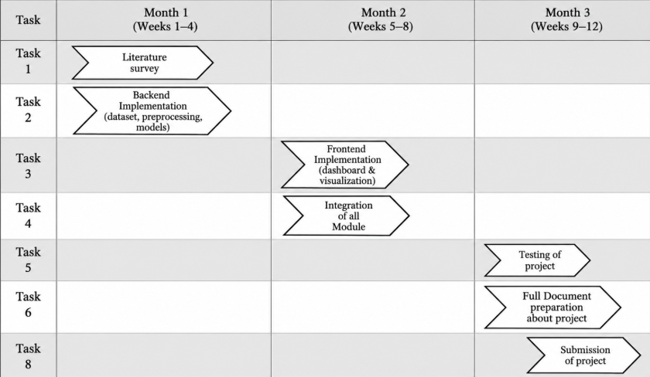
Fig. 1. Gantt chart
3. TECHNICAL SPECIFICATION
3.1 Requirements
The proposed system requires a web application environment that can generate and capture HTTP traffic plus mechanisms for session reconstruction, feature extraction, machine learning-based analysis, and real-time attack monitoring. The system should preserve the chronology between requests and analyse the characteristics of individual requests and the context of a session to classify the traffic into the five stages described (Normal, Reconnaissance, Fuzzing, Injection, and Exploitation). The system should also learn and evaluate the session-based dataset to produce outputs for attack tracking and alert generation.
3.1.1 Functional
- HTTP Traffic Collection: The system should be able to collect HTTP requests and responses from tools such as Burp Suite, proxy logs, or the application itself and preserve the relevant information from the requests and responses.
- Session Reconstruction: The system should be able to group related requests made within the same user session and preserve the chronological order of the requests in the session.
- Feature Extraction: The system should be able to extract request- and session-level features from the HTTP methods, paths, query parameters, headers, payloads, response information, and previous requests.
- Multi-Stage Classification: The system should be able to classify individual requests based on the five predefined attack stages: Normal, Reconnaissance, Fuzzing, Injection, and Exploitation.
- Sequential Analysis: The system should use sequential analysis of the requests in a given session to track the evolution of an attack instead of analysing individual requests.
- Next-Stage Forecasting: The system should use the model that captures the sequence of attack stages to forecast the next potential attack stage at specific points.
- Alert Generation: The system should generate alerts based on the detected attack stage and priority while preserving the session context.
- Performance Evaluation: The system should evaluate the performance of the attack detection and next-attack-stage forecasting based on the selected classification metrics, including accuracy, Macro-F1, transition accuracy, and false-positive rate, session-level attack detection rate, and next-stage forecasting accuracy.
3.1.2 Non-Functional
- Performance: The system should be able to process the incoming HTTP requests with a sufficiently low delay to enable timely attack detection and alert generation.
- Scalability: The system should be able to handle a growing number of HTTP requests and user sessions without a significant loss in performance.
- Reliability: The system should be able to produce consistent results in attack detection and preserve the session context even with the failure of individual requests or processing elements.
- Security: The system should ensure the security of the captured HTTP traffic, session context, and attack detection results to prevent unauthorized access or modification.
- Usability: The system should be able to provide a straightforward user interface for viewing the attack stages, attack forecasts, detection results, and alerts.
- Maintainability: The system should be designed in a modular way to allow for independent updates to separate elements, including attack detection, session tracking, and alert generation.
- Portability: The system must operate seamlessly across Linux and Windows environments and integrate cleanly as an inline reverse proxy or passive network tap with modern web servers (e.g., Nginx, Envoy, Traefik) without modifying application source code.
Compliance: The framework must adhere strictly to RFC 9110 HTTP/1.1 and HTTP/2 protocol semantics, align with OWASP Top 10 (A03:2021) injection defense guidelines, and comply with data privacy standards by automatically masking sensitive authorization credentials, session tokens, and passwords in logged session contexts.

  - 3.2 Feasibility Study

3.2.1 Technical Feasibility
- Technology Availability: The project involves technologies that are readily available, including programming languages such as Python, classification and sequential analysis techniques such as LSTM, XGBoost, and HMM, database systems such as MongoDB Atlas, and applications such as Burp Suite and OWASP Juice Shop.
- Technical Expertise: The project requires core competencies in Python software development, sequential deep learning (LSTM), tree ensembles (XGBoost), probabilistic state modeling (HMM), HTTP network traffic analysis, and application penetration testing—methodologies that are well-established within software engineering and cybersecurity research.
- Infrastructure: The development and evaluation infrastructure utilized standard multi-core CPU workstations for both model training and real-time streaming inference. All reported benchmark models—including the 3-seed LSTM, XGBoost, and HMM forward filter—were trained and evaluated on CPU architectures (with GPU usage restricted solely to preliminary exploratory trials), confirming that neither offline model training nor inline proxy deployment requires dedicated or expensive GPU hardware.
- Integration: The system components and modules can be integrated using an overall session tracking and feature extraction mechanism that will process the HTTP traffic and pass the extracted features to the attack detection and alert generation modules.
3.2.2 Economic Feasibility
- Development Cost: The development cost was kept minimal due to the availability of open-source and free programming frameworks, including Python, XGBoost, TensorFlow / Keras, Scikit-learn, Burp Suite Community Edition, OWASP Juice Shop, and Docker.
- Infrastructure Cost: The infrastructure cost can also be low due to the availability of computing resources to store the dataset in MongoDB Atlas and perform model training and testing.
- Cost-Benefit: The project demonstrates high economic feasibility by leveraging open-source software libraries (TensorFlow / Keras, XGBoost, Scikit-learn, hmmlearn, mitmproxy, and Docker) and open benchmark applications (OWASP Juice Shop), incurring zero proprietary licensing expenditure while delivering rigorous experimental validation.
- Resource Utilization: The project can be accomplished using readily available resources because it is a research-level project, and not a full-scale commercial application that requires significant infrastructure and financial resources.
3.2.3 Social and Ethical Feasibility
- User Acceptance: The system is designed to help security analysts by providing them with the relevant information about the current stage of an attack, the forecasted next attack stage, the level of urgency, and the alerts.
- Ease of Use: The monitoring interface can present the relevant sessions in a structured way to help security analysts easily identify the important elements of the intrusion detection results without having to examine the raw HTTP traffic.
- Ethical Considerations: All vulnerability assessments, penetration testing activities, payload injections, and HTTP traffic recordings were conducted strictly within an isolated, local containerized laboratory environment. The target web application (OWASP Juice Shop v15.0.0) was deployed within a standalone Docker container bound exclusively to localhost (127.0.0.1:9000). No public, university, commercial, or third-party production networks were targeted, probed, or monitored. Synthetic and automated attack sessions were generated adhering strictly to the ACM Code of Ethics and institutional research guidelines, ensuring zero risk of operational disruption, data leakage, or privacy infringement.
- Practical Impact: The system can be used in practice to help security analysts better track the progression of attacks and focus on the relevant requests and alerts within a single user session.

  - 3.3 System Specification

3.3.1 Hardware Specification
Processor (CPU): Intel Core i7-12700H (14 cores, 20 threads, base clock 2.30 GHz, max turbo 4.70 GHz) workstation processor, serving as the dedicated benchmark host environment for all reported model training, validation, and CPU-only streaming inference evaluations.
● Memory (RAM): Minimum 8 GB RAM to run the application and database simultaneously.
● Storage: Minimum 256 GB storage to store the application, database, data, results, and other supporting files.
Graphics Processing Unit (GPU): Optional for deployment. Dedicated NVIDIA GPU hardware was utilized for offline exploratory neural network experimentation; however, all reported benchmark models, training pipelines, and streaming inference evaluations were executed strictly on CPU (CUDA_VISIBLE_DEVICES=-1) to guarantee bit-reproducible execution and eliminate GPU hardware dependencies during live deployment.
● Monitor: Laptop screen or external monitor with a resolution of at least 1366 × 768.

3.3.2 Software Specification
● Operating System: Windows 10/11 or similar systems.
● Programming Languages: Python to perform data processing, machine learning, session tracking and analysis, and backend support.
● Development Environment: Visual Studio Code – to write and debug Python programs.
Libraries and Frameworks: Python 3.10+, TensorFlow/Keras v2.15.0 (CPU execution), XGBoost v2.0.3, scikit-learn v1.4.0, hmmlearn v0.3.2, NumPy v1.26.4, SciPy v1.11+, and BeautifulSoup v4.12.
● Database: MongoDB Atlas to store the session-based HTTP request and response data.
● Security Tools: Burp Suite Community Edition to capture HTTP traffic and OWASP Juice Shop to generate web application attack traffic.
4. DESIGN APPROACH AND DETAILS

4.1 System Architecture
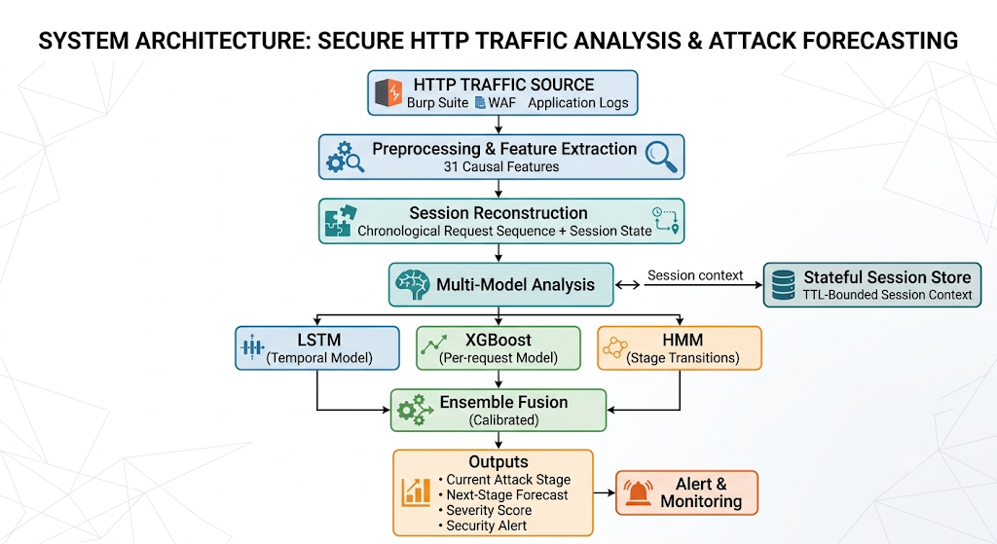
Fig. 2. System Architecture
The end-to-end processing architecture of the context-aware detection system is illustrated in Fig. 2. Incoming HTTP requests and responses are ingested in real-time via reverse proxy middleware hooks (e.g., mitmproxy, Nginx sidecars, or Burp Suite capture logs) and fed directly into the pre-processing and feature extraction engine. The module extracts the 31 causal features spanning request morphology, payload regex signatures, endpoint sensitivity classes, response diagnostics, and decaying sliding-window context. Transactions are aggregated into chronological sessions using client cookie and authorization tokens. The per-request feature vector is evaluated by the XGBoost tree ensemble, while the sequential feature trajectory is concurrently processed by the causal LSTM network. Model outputs are merged via equal-weight ensemble blending (alpha = 0.50) and calibrated via temperature scaling (T = 0.916) to provide the deployed current-stage prediction. In parallel, an HMM forward filter tracks the probabilistic transitions across the latent attack stages S_t in {0: Normal, 1: Recon, 2: Fuzzing, 3: Injection, 4: Exploitation}, supporting proactive next-distinct-stage attack intent forecasting and an optional lower-false-positive operating mode. The system outputs the predicted active stage, a normalized risk Severity Score defined as Severity(t) = SUM_{c=0}^4 w_c * P(S_t = c) where weights w = [0.0, 0.25, 0.50, 0.75, 1.00], the forecasted next distinct attack stage, and operational SOC alerts, all persisted within a TTL-bounded session store.
The architecture is causal, meaning that processing for a given request only considers the request and any requests that came before it, allowing the same pipeline to be used for both offline evaluation and online detection.
4.2 Design
The system design can be broken down into data flow, user interaction, structural components, and request-processing sequence. These designs dictate how HTTP traffic is received, processed and analysed, and how its resulting detection and forecasting information is conveyed to the security analyst.
4.2.1 Data Flow Diagram
Level 0 — Context Diagram — As illustrated in Fig. 3, the Level 0 Data Flow Diagram represents the complete intrusion detection framework as a unified system boundary interacting with external data sources and human analysts. HTTP/HTTPS client transactions are captured, processed against causal session contexts, and transformed into real-time stage predictions, alerts, and next-stage forecasts.
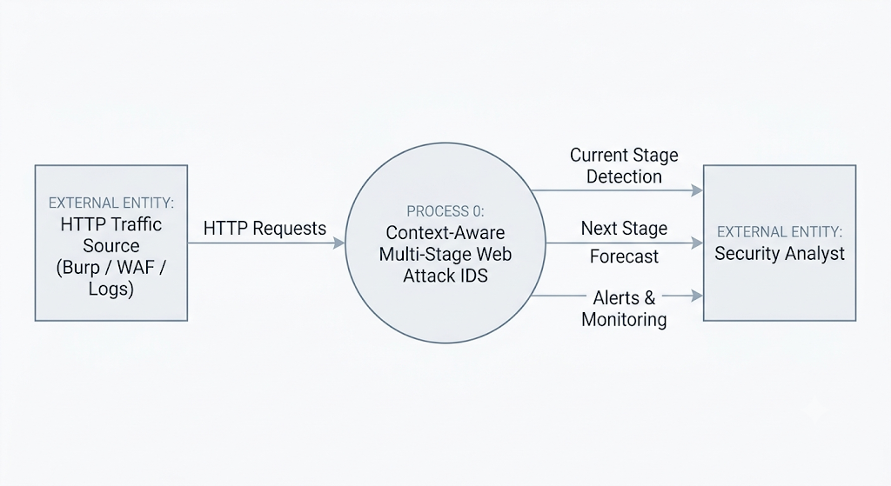
Fig. 3. Level 0 Context Data Flow Diagram
Level 1 — Detailed Data Flow — As depicted in Fig. 4, the Level 1 DFD decomposes the system into four core functional processes: (1.0) Traffic Interception & Session Demultiplexing, (2.0) 31-Dimensional Causal Feature Extraction, (3.0) Multi-Tiered Machine Learning & HMM Forward Inference, and (4.0) Session State Tracking, Alert Scoring, and Intent Forecasting. A stateful session store maintains sliding history context, while a Time-To-Live (TTL) expiration mechanism evicts dormant sessions to prevent state bloat.
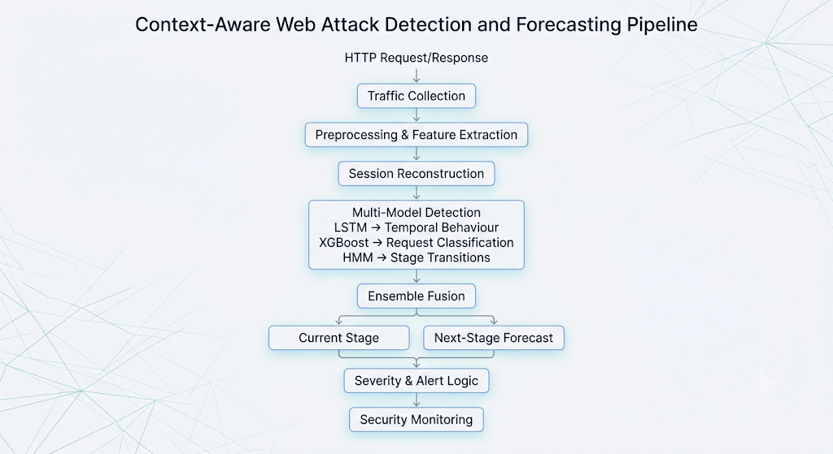The session store operates alongside the processing flow and maintains the contextual state required for subsequent requests. A TTL mechanism prevents stale session information from influencing later detections.
Fig. 4. Level 1 Detailed Data Flow Diagram
4.2.2 Use Case Diagram
As illustrated in the system Use Case Diagram shown in Fig. 5, the primary human actor is the Security Operations Center (SOC) Analyst, who configures detection thresholds, inspects real-time stage progression telemetry, reviews severity scores, and investigates high-urgency intrusion alerts. The HTTP Traffic Source acts as an external system boundary providing raw HTTP request/response streams, while the automated IDS engine executes feature extraction, stage inference, state persistence, and mitigation dispatch.
Actors
• HTTP Traffic Source: provides HTTP request and response to the system.
• Security Analyst: monitors detected stages, forecasts, and alerts.
• IDS: system processes the traffic, keeps sessions, does detections, and produces results.

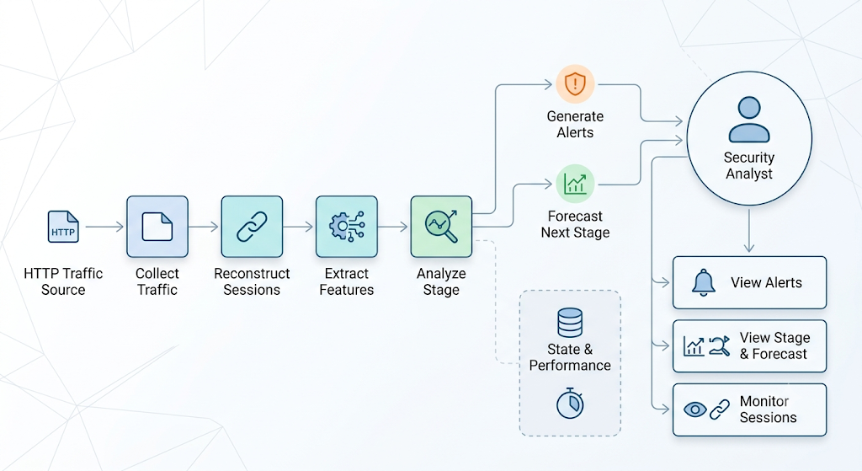
Fig. 5. System Use Case Diagram
4.2.3 Class Diagram
The object-oriented software architecture of the system is structured as shown in the Class Diagram in Fig. 6. The HTTPRequest class encapsulates individual transaction metadata; the Session class manages the chronological request deque and rolling context; the SessionFeatureExtractor implements the 31 causal feature algorithms; the XGBoostPredictor and LSTMModel execute neural and tree inferences; the HMMFilter executes Bayesian forward tracking; and the EnsembleDetector orchestrates calibrated probability blending, severity scoring, and alert dispatch.
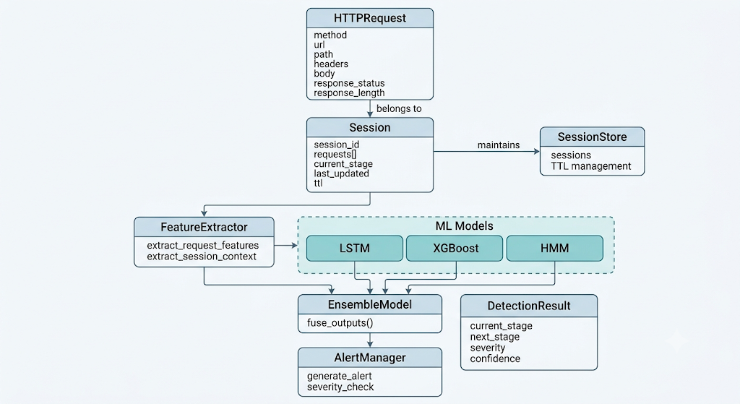
Fig. 6. System Class Diagram
4.2.4 Sequence Diagram
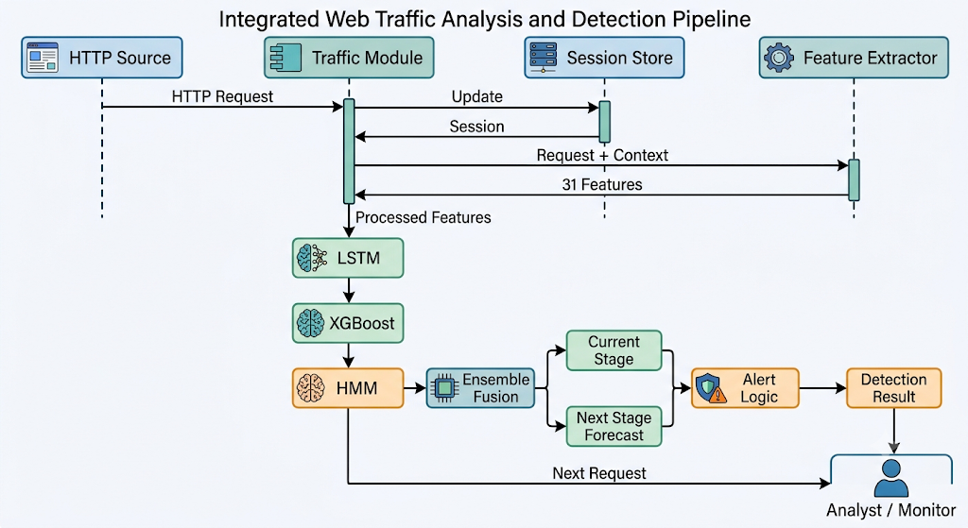
Fig. 7. Sequential Processing Sequence Diagram
The runtime sequence of operations is depicted in the Sequence Diagram in Fig. 7. For every incoming HTTP request, the system first identifies the active session ID, retrieves the bounded historical context, and computes the 31-dimensional causal feature vector. The feature vector is concurrently evaluated by the XGBoost classifier and the recurrent LSTM network. The resulting posterior probabilities are blended and passed to the HMM forward filter to update the latent stage belief state. The system outputs the predicted stage, calculates the severity score, generates proactive alerts if thresholds are breached, and updates the session store for the subsequent request. Strict causality is maintained throughout: no future transaction is ever accessed during current-request inference.
5. IMPLEMENTATION AND EXPERIMENTAL METHODOLOGY
5.1 Implementation Environment and Specifications
To establish an authentic, leak-free, and reproducible experimental platform, the entire detection, feature extraction, model training, and sequential evaluation pipeline was deployed on dedicated laboratory hardware. Rather than relying on abstract mathematical simulations, real-world production-grade software frameworks, bidirectional network interception proxies, containerized web applications, and machine learning toolkits were fully integrated. The complete hardware architecture and software stack of the experimental implementation environment is documented in Table 1.
Table 1: Hardware and Software Implementation Environment Specifications
Component | Experimental Specification | Functional Role in System
Operating System | Microsoft Windows 11 Enterprise (64-bit) | Host execution runtime and container hypervisor
Host Processor (CPU) | Intel Core i7-12700H (14 cores, 20 threads @ 2.30 GHz) | Model training, online feature extraction & real-time inference
System Memory (RAM) | 16 GB DDR4 (3200 MHz) | Session deque caching and batch corpus processing
Storage Subsystem | 512 GB NVMe M.2 Solid State Drive | Log persistence and model weight serialization
GPU / Accelerator | NVIDIA GeForce GTX 1650 (Exploratory prototyping only; all reported benchmark models, training routines, and streaming inference evaluations executed strictly on CPU for deployment portability and bit-stable reproducibility) | Offline exploratory prototyping
Programming Language | Python 3.10.12 (64-bit virtualenv) | End-to-end pipeline implementation and evaluation
Tree Ensemble Framework | XGBoost v2.0.3 (Hist gradient boosting) | Per-request tabular stage classification
Deep Learning Framework | TensorFlow / Keras v2.15.0 (CPU execution) | 3-seed recurrent LSTM temporal sequence encoding
Markov Modeling Library | hmmlearn v0.3.2 / NumPy v1.26.4 / SciPy v1.11+ | Supervised Bayesian forward belief filtering
Machine Learning Suite | scikit-learn v1.4.0 | Feature scaling, probability calibration & metrics
Interception Proxy | mitmproxy v10.1.5 / Burp Suite Community | Bidirectional HTTP/1.1 and HTTP/2 traffic interception
Vulnerable Testbed | OWASP Juice Shop v15.0.0 (Docker) | Locally containerized, network-isolated web application target
5.2 Five-Stage Web Injection Attack Taxonomy and Scope Definition
Enterprise web injection campaigns unfold through progressive operational phases. To provide granular situational awareness and avoid the blunt binary (malicious vs. benign) labeling of legacy intrusion detection systems, this research formalizes a five-stage operational attack taxonomy: Normal, Reconnaissance, Fuzzing, Injection, and Exploitation. While conceptually informed by established industry frameworks—specifically the Lockheed Martin Cyber Kill Chain and the MITRE ATT&CK Matrix for Enterprise—this taxonomy is designed as an operational engineering classification tailored specifically for application-layer HTTP session monitoring, rather than asserting a strict one-to-one mapping to high-level threat matrices. Each HTTP transaction within a session is mapped to one of the five stages detailed in Table 2.
Table 2: Five-Stage Web Injection Attack Taxonomy and Operational Scope Definition
Stage | Phase Name | MITRE ATT&CK Mapping | Operational Objective & Scope | Sample HTTP Transaction
Stage 0 | Normal | Legitimate Interaction | Authorized user browsing, product search, cart updates, and checkout | GET /rest/products/search?q=apple
Stage 1 | Reconnaissance | Active Scanning (T1595 / T1595.003 Wordlist Scanning) / Endpoint Probing | Endpoint discovery, hidden directory probing, schema fingerprinting | GET /api/Challenges, /ftp, robots.txt
Stage 2 | Fuzzing | Active Scanning: Vulnerability Scanning (T1595.002) / Input Probing | Input boundary testing, abnormal delimiters, parser exception induction | GET /rest/products/search?q=-99999999 (Negative limit & boundary probe without SQL syntax)
Stage 3 | Injection | Exploit Public-Facing Application (T1190: SQL syntax verification & payload delivery)* | Active SQL syntax verification, UNION queries, boolean-blind probes | GET /rest/products/search?q=' UNION SELECT 1,id,email FROM Users--
Stage 4 | Exploitation | Credential Access (T1212) / Exfiltration (T1005) | Authentication bypass, admin credential extraction, unauthorized data dump outcome | POST /rest/user/login (admin'--) -> 200 OK + Admin JWT issued; unauthorized credential exfiltration
*Note: MITRE ATT&CK associations are illustrative behavioral mappings for application-layer analysis rather than asserting strict one-to-one equivalence, as Stage 3 represents active SQL syntax verification and injection probing prior to confirmed unauthorized impact (Stage 4).
5.3 Dataset Construction and In-House Testbed
To evaluate multi-stage web injection attacks in a realistic, reproducible, and ethically sound setting, an in-house experimental testbed was deployed. Modern web injection campaigns rarely consist of isolated, out-of-context exploit payloads; instead, attackers systematically progress through reconnaissance, input space fuzzing, syntax verification, and finally exploit execution. Standard benchmark intrusion datasets such as KDD-99 or NSL-KDD lack application-layer HTTP semantics, whereas repositories like CICIDS-2017 collapse attack chains into independent packet samples without preserving session state. Consequently, a dedicated, session-aware experimental corpus was constructed using the OWASP Juice Shop (v15.0.0) vulnerable web application.
The Juice Shop application was containerized using Docker and hosted on an isolated loopback network interface (127.0.0.1:9000). Traffic generation was partitioned into two distinct streams: (1) Benign traffic was produced using automated client browsing harnesses simulating legitimate e-commerce user behavior—including catalog navigation, product keyword search, user review perusal, basket updates, checkout flows, and user registration; (2) Malicious multi-stage traffic was generated using automated penetration testing harnesses (including Burp Suite Intruder, SQLmap, and custom Python requests scripts) coupled with manual vulnerability verification following the OWASP Web Security Testing Guide. Interception proxies, specifically mitmproxy and Burp Suite Community Edition, recorded all bidirectional HTTP/1.1 and HTTP/2 transactions, capturing full URI paths, request headers, query parameters, POST body payloads, HTTP response status codes, response byte sizes, and inter-arrival timestamps. The resulting raw capture pool comprises 62 distinct XML capture files containing 2,878 unique captured HTTP requests across 5 HTTP methods, 13 status codes, and 653 unique URI endpoints.
Dataset Provenance and Block-Level Session Composition: Because individual capture runs contain limited sequence lengths, multi-request sessions were assembled using a block-level kill-chain Markov process (implemented in pipeline/compose.py). Rather than generating synthetic text strings, the composition engine samples contiguous blocks of real, captured requests (block lengths ranging from 3 to 16 requests) from the capture pool. Across the entire corpus of 2,100 sessions totaling 72,269 request instances, the underlying 2,878 captured requests (alongside approximately 1,200 live-response requests added exclusively to the training split) are resampled approximately 17 times on average. The generative process transitions between attack rungs (Reconnaissance -> Fuzzing -> Injection -> Exploitation) while incorporating retreats, pauses, and skips, as well as an 18% proportion of erratic sessions with near-uniform stage transitions. This reduced the fraction of monotonically escalating sessions from 1.0 down to ~0.70, ensuring non-trivial temporal dynamics. It is acknowledged as a methodological characteristic that because session sequences are assembled via this Markov progression grammar, the Hidden Markov Model transition dynamics estimated during training partly reflect the generator's underlying transition rules.
Deterministic Five-Stage Request Labeling Rules: To resolve syntactic ambiguities between operational phases, explicit labeling criteria were applied across all five stages:
1. Stage 0 (Normal): Standard legitimate user navigation, product catalog queries with alphanumeric keywords, static asset retrievals (e.g., /assets/public/images), profile updates, and regular authentication attempts lacking metacharacters or anomalous headers.
2. Stage 1 (Reconnaissance): Systematic application surface mapping and endpoint enumeration, including requests probing hidden routes (/admin, /api/Challenges, /rest/user/whoami), technology profiling, directory discovery, and parameter probing without active injection syntax.
3. Stage 2 (Fuzzing): Deliberate parameter boundary and exception testing, including submitting boundary integers (-1, 0, 999999), single metacharacters (', ", <), malformed delimiters, and unexpected data types designed to elicit server error codes (4xx/5xx) or verbose database diagnostics without structured SQL or script execution.
4. Stage 3 (Injection): Multi-token structured injection payloads targeting interpreter manipulation, including boolean SQL clauses (' OR '1'='1), UNION SELECT statements, inline SQL comments (--), XSS script tags (<script>alert(1)</script>), and attribute event handlers. The empirical recall on Injection is 25.8% (0.2583) because many subtle injection requests share structural tokens with fuzzing probes, leading the classifier to conservatively assign Fuzzing until multi-token syntax is established.
5. Stage 4 (Exploitation): Payloads achieving verified security compromise, including authentication bypass yielding administrative JWT tokens (admin'--), unauthorized execution of administrative functions (/rest/admin/application-configuration), privilege escalation, or sensitive credential extraction (/api/Users/1).
File-Disjoint Partitioning Protocol: To prevent data leakage, the corpus enforces a strict file-disjoint partitioning protocol before session composition (pipeline/corpus.py: assign_file_splits). The 62 source XML capture files were partitioned into disjoint subsets: 40 files assigned to training, 10 files to validation, and 12 files to the held-out test split. Multi-stage sessions were composed by sampling request blocks exclusively from capture files assigned to that session's designated split; no source block or request sequence crosses a split boundary. While common application endpoints (e.g., /rest/user/login, /rest/products/search) and standardized scanner payload patterns (e.g., from Intruder or SQLmap wordlists) legitimately occur across partitions as in operational web traffic, source capture files and raw request blocks are strictly split-disjoint. The final corpus comprises 2,100 complete sessions totaling 72,269 HTTP request instances: 1,500 sessions (50,975 requests) in training, 300 sessions (11,120 requests) in validation, and 300 sessions (10,174 requests) in the held-out test split. In the held-out test split, 34 sessions are fully benign (835 requests) and 266 sessions contain attack sequences (9,339 requests). Results are reported on this held-out file-disjoint test partition; the limitation of evaluating on a single 300-session test split without multi-fold cross-validation confidence intervals is noted and discussed in Section 7.6.
Table 3: Summary of the Experimental Dataset and Request Distribution Across Attack Stages
Dataset Metric / Attack Stage | Training Set | Validation Set | Held-Out Test Set | Total Corpus
Source Capture Files | 40 | 10 | 12 | 62
Unique Raw Requests in Pool | ~1,700 + ~1,200 live | ~580 | ~600 | ~4,080
Composed User Sessions | 1,500 | 300 | 300 | 2,100
Purely Benign Sessions (Peak = 0) | 168 (11.2%) | 32 (10.7%) | 34 (11.3%) | 234 (11.1%)
Attack Sessions (Peak >= 1) | 1,332 (88.8%) | 268 (89.3%) | 266 (88.7%) | 1,866 (88.9%)
Total Composed Request Instances | 50,975 | 11,120 | 10,174 | 72,269
Stage 0: Normal Requests | 14,373 (28.2%) | 3,067 (27.6%) | 2,900 (28.5%) | 20,340 (28.1%)
Stage 1: Reconnaissance Requests | 11,993 (23.5%) | 2,806 (25.2%) | 2,400 (23.6%) | 17,199 (23.8%)
Stage 2: Fuzzing Requests | 9,106 (17.9%) | 2,237 (20.1%) | 1,758 (17.3%) | 13,101 (18.1%)
Stage 3: Injection Requests | 8,367 (16.4%) | 1,768 (15.9%) | 1,699 (16.7%) | 11,834 (16.4%)
Stage 4: Exploitation Requests | 7,136 (14.0%) | 1,242 (11.2%) | 1,417 (13.9%) | 9,795 (13.6%)
As reported in Table 3 and illustrated in Fig. 8, the total request count across splits is 50,975 in training, 11,120 in validation, and 10,174 in the held-out test set (overall total: 72,269 request instances). The average session length is 34.0 requests in training, 37.1 requests in validation, and 33.9 requests in the test set. Class balance across all three partitions is consistent, with Normal traffic comprising ~28%, Reconnaissance ~24%, Fuzzing ~18%, Injection ~16%, and Exploitation ~14%. While evaluating on a single target application (Juice Shop) enables deep semantic modeling of full attack chains, it represents an acknowledged boundary condition; evaluating cross-application generalization against additional targets (e.g., DVWA, WebGoat) constitutes an important future research objective discussed in Section 7.6.
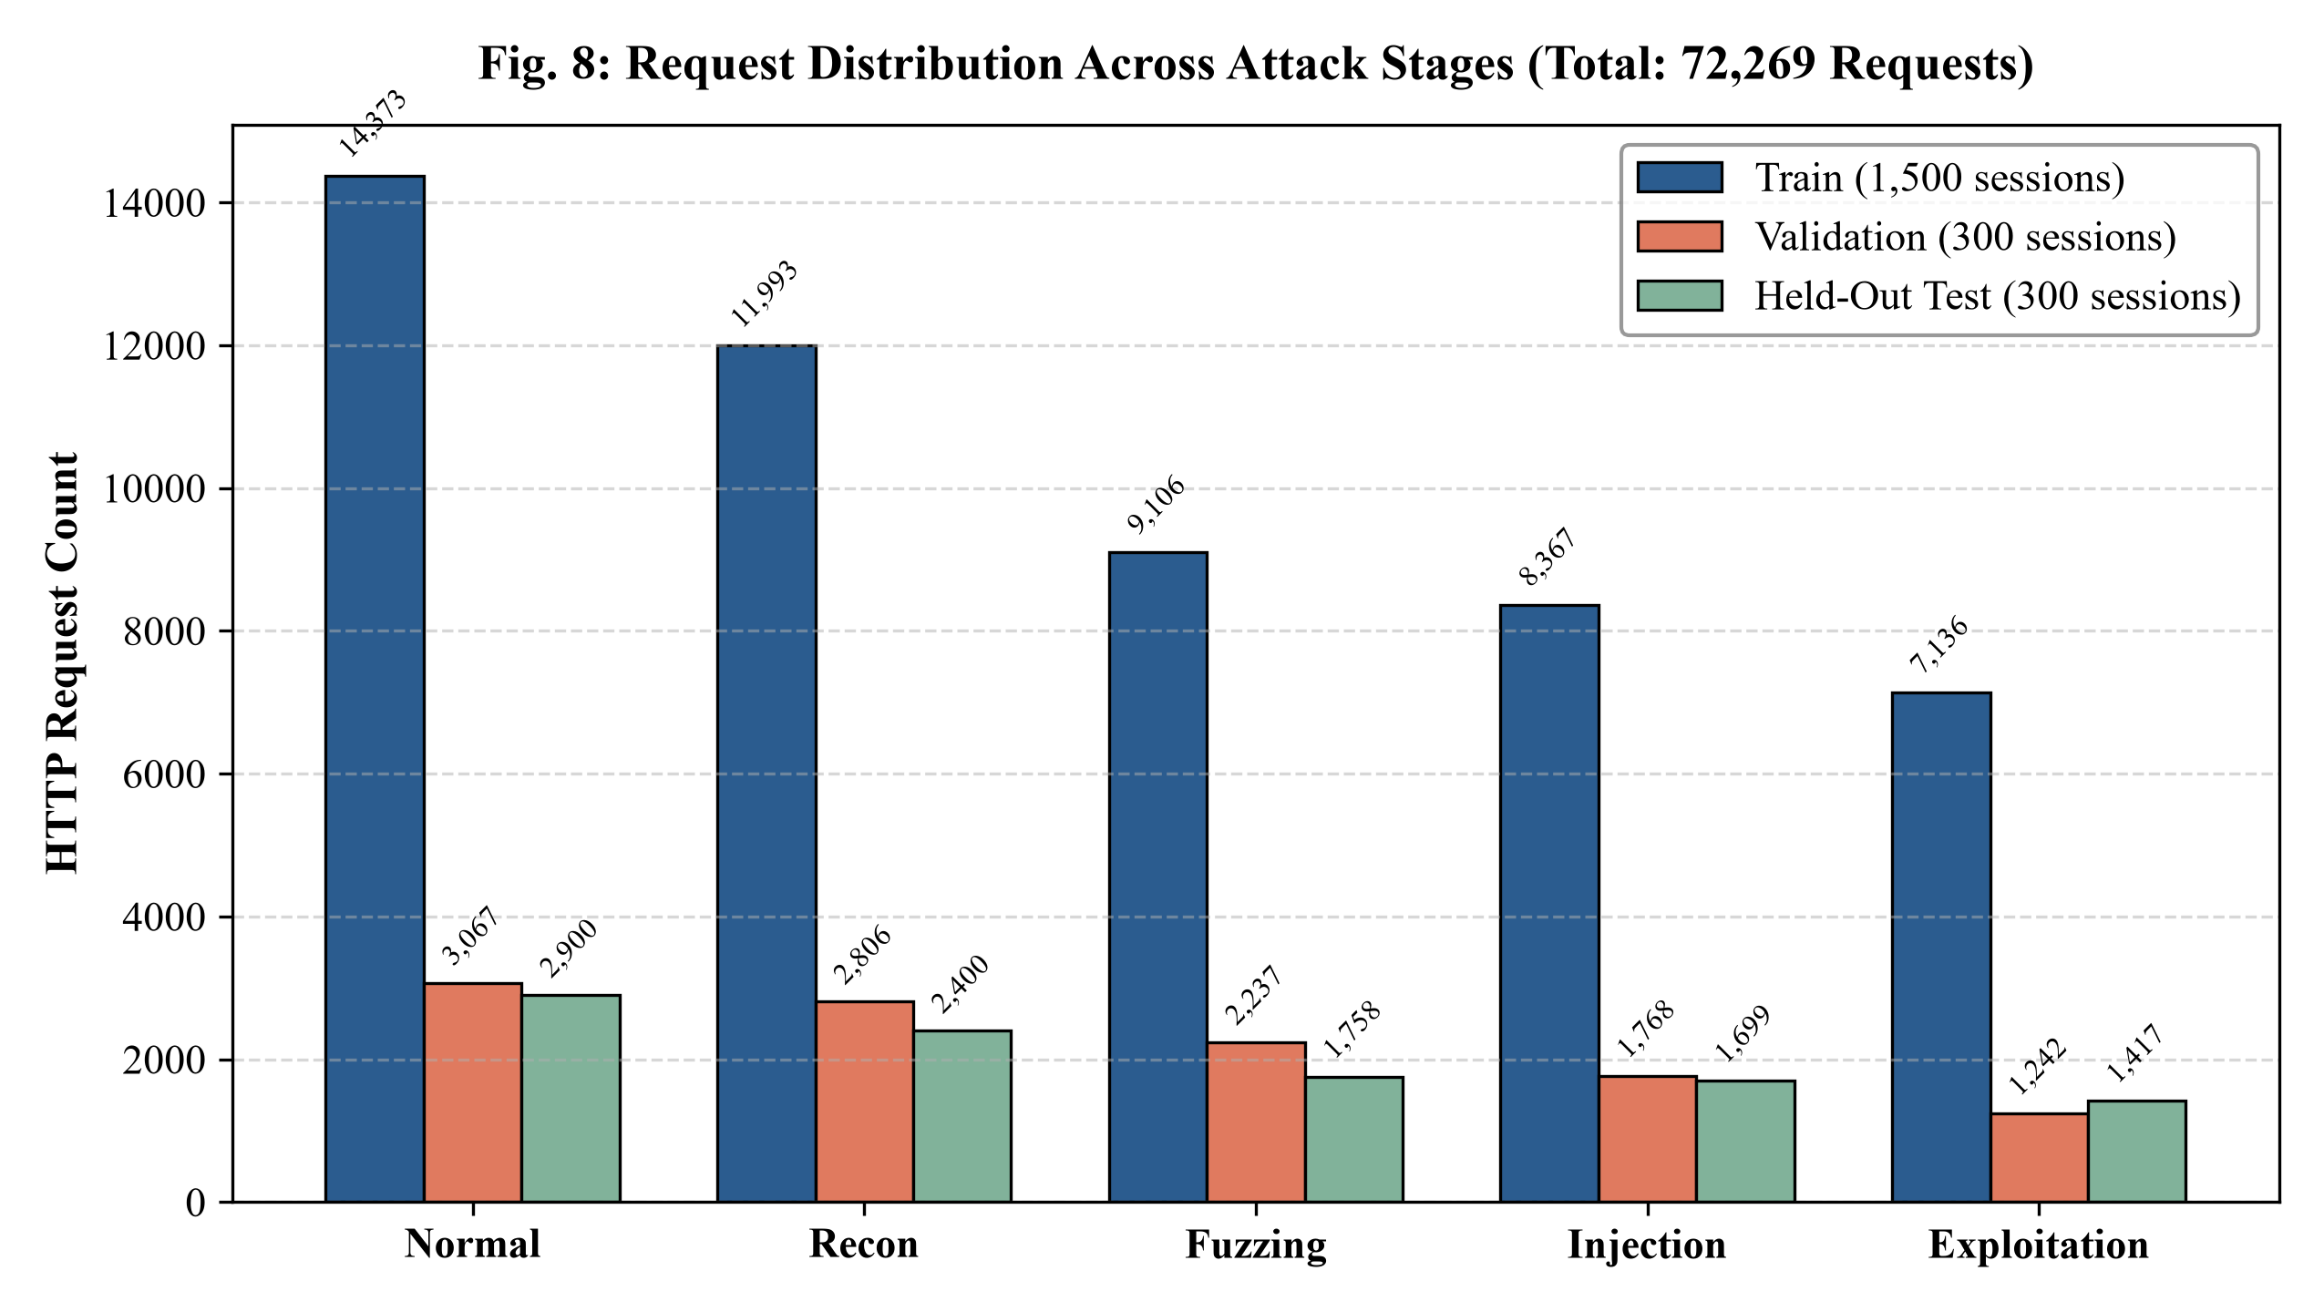
Fig. 8. Request Distribution Across Attack Stages (Train, Validation, and Test Sets)
5.4 The 31 Causal Feature Engineering Framework
Feature engineering in intrusion detection systems must satisfy strict temporal causality. A feature vector extracted at time step t, denoted f_t, is strictly causal if and only if it is a mathematical function solely of the current request r_t and the historical sequence of prior requests within the same session: f_t = phi(r_1, r_2, ..., r_t). If a feature extraction routine computes statistics over the entire completed session (for instance, the total number of distinct endpoints visited across all requests 1 to T), the detector commits lookahead cheating: at request t=2, it uses knowledge of requests occurring at t=50. Such non-causal systems exhibit artificially inflated laboratory benchmark accuracy but fail completely when deployed in live, streaming proxy environments.
To enforce absolute causality, the feature extraction engine (implemented in SessionFeatureExtractor) operates as an online state machine. It maintains a bounded sliding history window (window size W = 8) and an exponential decay context model (decay rate gamma = 0.6). Unbounded quantities, such as query string lengths, payload byte counts, and inter-arrival times, are stabilized using log1p compression (log(1 + x)) to prevent extreme outlier values from distorting neural gradient descent. A comprehensive schema of 31 causal features was engineered across five distinct operational categories, as detailed in Table 4.
Table 4: The 31 Causal Features Schema Across Five Functional Categories
# | Feature Key | Functional Category | Mathematical Definition and Security Relevance
1 | is_get | Request Morphology | Binary indicator: 1 if HTTP method is GET, 0 otherwise.
2 | is_post | Request Morphology | Binary indicator: 1 if HTTP method is POST, 0 otherwise.
3 | is_write | Request Morphology | Binary indicator: 1 if method is PUT, PATCH, or DELETE (state mutation).
4 | path_depth | Request Morphology | Integer count of URI path segments separated by slashes.
5 | has_query | Request Morphology | Binary indicator: 1 if query parameter string is non-empty.
6 | log_query_len | Request Morphology | Log1p compressed length of query parameter string: ln(1 + len(query)).
7 | log_body_len | Request Morphology | Log1p compressed length of POST/PUT body payload in bytes.
8 | query_param_count | Request Morphology | Total count of parsed query parameters.
9 | special_char_ratio | Request Morphology | Proportion of punctuation, quotes, and non-alphanumeric symbols in query and body.
10 | sqli_score | Payload Regex Signatures | Count of SQL injection keyword and syntax pattern matches (UNION, SELECT, WHERE, OR, comments --, #).
11 | xss_score | Payload Regex Signatures | Count of XSS HTML tag and JavaScript event handler patterns (<script>, onerror=, onload=, alert).
12 | numeric_query | Payload Regex Signatures | Binary indicator: 1 if query parameter values consist strictly of numeric digits.
13 | boundary_value | Payload Regex Signatures | Binary indicator: 1 if input values contain boundary probes (-1, 0, 999999, null, NaN).
14 | admin_path | Endpoint Sensitivity | Binary indicator: 1 if URI contains administrative tokens (/admin, /administration, /metrics).
15 | api_path | Endpoint Sensitivity | Binary indicator: 1 if URI targets REST API routes (/api/, /rest/).
16 | auth_path | Endpoint Sensitivity | Binary indicator: 1 if URI targets authentication routes (/login, /auth, /oauth, /rest/user/login).
17 | search_path | Endpoint Sensitivity | Binary indicator: 1 if URI targets product keyword search routes (/rest/products/search).
18 | has_auth_header | Endpoint Sensitivity | Binary indicator: 1 if Authorization header (e.g., Bearer token) is present.
19 | has_identity_header | Endpoint Sensitivity | Binary indicator: 1 if user identity headers (X-User-Email, X-Forwarded-For) are present.
20 | status_2xx | Response Diagnostics | Binary indicator: 1 if HTTP response status code is in the 2xx range (Success).
21 | status_3xx | Response Diagnostics | Binary indicator: 1 if HTTP response status code is in the 3xx range (Redirection).
22 | status_4xx | Response Diagnostics | Binary indicator: 1 if HTTP response status is in the 4xx range (Client Error, e.g., 401, 404).
23 | status_5xx | Response Diagnostics | Binary indicator: 1 if HTTP response status is in the 5xx range (Server Error, e.g., 500 unhandled exception).
24 | log_resp_len | Response Diagnostics | Log1p compressed length of HTTP response payload in bytes: ln(1 + len(resp)).
25 | log_request_index | Decaying Session Context | Chronological index of request within the active user session: ln(1 + t).
26 | log_inter_arrival | Decaying Session Context | Log1p compressed elapsed time in seconds since the previous request in session: ln(1 + Delta t).
27 | endpoint_diversity_recent | Decaying Session Context | Number of distinct URI endpoints accessed across the sliding window (W = 8).
28 | path_diversity_recent | Decaying Session Context | Number of distinct URI base paths accessed across the sliding window (W = 8).
29 | error_rate_recent | Decaying Session Context | Fraction of requests in the sliding window (W = 8) that produced 4xx or 5xx response statuses.
30 | attack_pressure | Decaying Session Context | Exponential moving average of payload signature scores: C_t = gamma * C_{t-1} + (1 - gamma) * (sqli_score + xss_score) with gamma = 0.6.
31 | enum_pressure | Decaying Session Context | Rolling count of distinct parameterized probes in the window (W = 8), capturing systematic directory/parameter brute-forcing.
The engineered feature space systematically decouples orthogonal signals: Features 1 to 9 capture request morphology and syntax density; Features 10 to 13 flag malicious payload signatures and boundary probes; Features 14 to 19 evaluate target endpoint criticality and privilege context; Features 20 to 24 capture application response diagnostics; and Features 25 to 31 maintain causal temporal session memory. Because context features use bounded sliding windows (W = 8) and exponential decay rather than infinite accumulators, a legitimate user who inadvertently triggers a 404 error is not permanently penalized for the remainder of their session.
5.5 Machine Learning Baseline Models
To isolate the contribution of temporal sequence modeling, a progressive hierarchy of detection models was implemented and benchmarked, ranging from parameter-free heuristics to state-of-the-art non-linear classifiers:
1. Parameter-Free Baselines: The Majority Class baseline perpetually assigns the most frequent training label (Normal, Stage 0), providing a minimum floor for accuracy (28.50%). The Zero-Parameter Current-Request Lookup maps individual HTTP status codes and regex hits directly to stages using fixed rules. The Zero-Parameter Running-Max Lookup maintains the highest severity stage observed so far in the session, achieving 29.95% accuracy. These baselines represent conventional signature-matching firewalls.
2. Gradient Boosted Decision Trees (XGBoost): A per-request non-linear tree ensemble trained using the XGBoost framework. The model operates on the 31-dimensional feature vector x_t. Although x_t incorporates rolling context features (Features 25 to 31, such as error_rate_recent and attack_pressure), the XGBoost classifier itself is non-recurrent and stateless; it evaluates each request vector independently without internal recurrent memory or hidden state propagation. Hyperparameters were tuned on the validation set: max_depth = 6, n_estimators = 100, learning_rate = 0.10, subsample = 0.8, colsample_bytree = 0.8, and multi:softprob objective function. XGBoost serves as a high-capacity single-request baseline.
3. Long Short-Term Memory (LSTM) Recurrent Neural Network: A sequential deep neural network designed to capture temporal transitions across successive HTTP requests. The network architecture consists of an input layer accepting 31-dimensional feature vectors, two stacked causal LSTM layers with 64 hidden units each, a dropout layer (rate = 0.20) to mitigate overfitting, and a Dense linear layer with Softmax activation outputting posterior class probabilities over the five stages. The model is trained using the Adam optimizer (learning rate = 0.001) with categorical cross-entropy loss over 30 epochs on sliding history windows (T <= 10). To eliminate stochastic initialization variance, models were trained across three distinct random seeds (Seed 42, 43, 44), and the seed-averaged ensemble prediction is reported. On modern AVX2-enabled CPU hardware, evaluating this 3-seed ensemble across bounded sliding windows requires only 0.11 ms per request.
5.6 Hidden Markov Model (HMM) Transition Dynamics
Web intrusion attacks follow an underlying stochastic process governed by attacker objectives and defensive feedback. Attack progression is formalized using a discrete-time Hidden Markov Model (HMM) defined by the 5-tuple lambda = (S, V, A, B, pi):
Hidden States: S = {s_0: Normal, s_1: Reconnaissance, s_2: Fuzzing, s_3: Injection, s_4: Exploitation}. At any time step t, the attacker or benign user occupies exactly one unobservable latent stage q_t in S representing their true operational phase.
Transition Probability Matrix: A in R^{5 x 5}, where A_{ij} = P(q_{t+1} = s_j | q_t = s_i) represents the probability of transitioning from stage s_i to stage s_j. Transition probabilities are estimated directly from empirical state sequences in the training set with additive Laplace smoothing (smoothing parameter lambda_s = 0.20 selected via grid search on the validation set).
Observation Emissions and Forward Filtering: In classical discrete HMMs, emissions represent categorical tokens from a codebook. In this hybrid neural-HMM architecture, the continuous observation vector is the calibrated posterior probability distribution P_cal(y_t = s_j | x_t) emitted by the neural and tree classifiers. By Bayes' rule, the observation likelihood is proportional to P(x_t | q_t = s_j) proportional to P(q_t = s_j | x_t) / P(q_t = s_j). Under an uninformative uniform state prior (P(q_t = s_j) = 1/K), the emission likelihood is directly proportional to the calibrated posterior e_{t, j} = P_cal(y_t = s_j | x_t). The causal forward algorithm recursively computes the joint forward variable alpha_t(j) = P(x_1, ..., x_t, q_t = s_j | lambda):
alpha_t(j) = e_{t, j} * SUM_{i=0}^4 [ alpha_{t-1}(i) * A_{ij} ]
The causal belief distribution b_t in R^5 is obtained by normalizing the forward variables: b_t(j) = alpha_t(j) / SUM_{k=0}^4 alpha_t(k). Crucially, the forward filter is strictly causal: it requires only past observations x_1 to x_t and can be evaluated online with O(1) time complexity per request (0.02 ms). In contrast, the classic Viterbi algorithm computes the globally optimal state sequence using dynamic programming over the entire completed session 1 to T. While Viterbi provides a retrospective offline sequence decoding benchmark, it is inherently non-causal because decoding state q_t requires backward traceback from future observation x_T, making it unsuitable for real-time inline blocking.
5.7 Causal Ensemble Architecture and Decision Logic
Neither standalone decision trees nor recurrent neural networks provide optimal detection across all operating regimes. XGBoost reacts instantaneously to acute payload anomalies (such as explicit SQL injection strings) but exhibits high false-positive rates on complex benign URLs. Conversely, LSTM excels at tracking smooth temporal trends but can suffer from transition inertia when an attacker abruptly pivots from reconnaissance to exploit delivery. To synthesize the strengths of both paradigms, a Causal Ensemble is implemented.
The ensemble fuses the per-request class probabilities through linear probability blending:
P_ens(y_t = c) = alpha * P_LSTM(y_t = c) + (1 - alpha) * P_XGB(y_t = c)
Empirical validation across alpha in [0.0, 1.0] in increments of 0.10 confirmed that an equal blending weight (alpha = 0.50) yields the highest Macro-F1 score on validation data. To ensure that the blended probability distributions reflect true empirical probabilities, post-hoc Temperature Scaling [10] is applied to calibrate the blended logits:
P_cal(y_t = c) = exp(z_c / T) / SUM_{k=0}^4 exp(z_k / T)
where z is the unnormalized logit vector and T is the learned temperature scalar. Temperature scaling optimizes a single global parameter T > 0 to rescale logits without altering class ranking or argmax predictions, distinct from two-parameter sigmoid Platt scaling. Calibration optimization on the validation partition converged to T = 0.916 on the ensemble logits (and T = 1.3485 on raw LSTM outputs), reducing the Expected Calibration Error (ECE) from 15.68% down to 8.38%. The calibrated ensemble distribution P_cal provides the deployed current-stage prediction, while the HMM forward filter computes the causal belief state b_t dedicated to next-distinct-stage forecasting and providing an optional low-false-positive operating mode.
5.8 Evaluation Metrics
To rigorously quantify performance across request-level classification, sequential transition fidelity, false alarm rates, and operational SOC utility, seven distinct mathematical metrics are evaluated on the held-out test set:
1. Overall Accuracy: The fraction of total requests whose predicted stage matches the ground-truth stage: Acc = (1 / N) * SUM_{t=1}^N I(hat{y}_t = y_t), where N = 10,174.
2. Macro-Averaged F1-Score (Macro-F1): The unweighted arithmetic mean of F1-scores across all K = 5 classes: Macro-F1 = (1 / K) * SUM_{c=0}^{K-1} [ 2 * P_c * R_c / (P_c + R_c) ], where P_c and R_c represent class-specific precision and recall.
3. Transition Edge Accuracy: Evaluates classification fidelity specifically at state change boundaries and sequence onsets. Let E = { t in {1, ..., T} | t = 1 or y_t != y_{t-1} } denote the set of transition points (|E| = 1,054 across the 300 test sessions). Transition Edge Accuracy is computed as: Edge_Acc = (1 / |E|) * SUM_{t in E} I(hat{y}_t = y_t), measuring how accurately the model captures dynamic phase shifts rather than relying on intra-block persistence.
4. Benign False-Positive Rate (FPR) and Session False Alarm Rate: Request-level Benign FPR measures the proportion of legitimate (Stage 0: Normal) requests incorrectly classified as an attack: FPR = FP_Normal / (FP_Normal + TN_Normal). Complementing this, Session-Level False Alarm Rate (FAR) is evaluated strictly on the 34 pure-benign sessions in the test set: Session_FAR = (Benign Sessions with >= 1 False Alarm) / (Total Pure-Benign Sessions), quantifying how frequently legitimate user sessions trigger disruptive operational alerts.
5. Session-Level Campaign Detection Rate: Measures the operational probability that an attacking session is detected before completion. For all 266 test sessions whose true peak stage reaches an attack stage (s >= 1), evaluation assesses whether the running predicted stage ever reaches or exceeds that peak stage: Catch_Rate(s) = Caught_Sessions(s) / Total_Sessions(s).
6. Early Detection Latency & Lead Time: For each caught attack session, detection latency L_det is the number of requests of the peak attack stage processed before the detector raises an alert: L_det = t_alert - t_peak_onset. The operational lead-time metric measures the number of requests elapsed between the initial alarm and the final exploitation payload delivery, providing defenders with tactical response margin.
7. Next-Distinct-Stage Intent Forecasting Accuracy: Evaluated strictly at real phase transitions (points where true stage y_{t+1} != y_t, n = 754 in the test corpus). Because raw adjacent-request pairs exhibit 92.36% persistence due to block structure, predicting y_{t+1} = y_t is trivial during steady-state runs. Meaningful intent forecasting requires predicting the next distinct stage when a transition occurs. Using the transition matrix with self-loops removed, B = norm(A - diag(A)), the model forecasts the next distinct stage via v_next = b_t * B. Top-1 and Top-2 accuracy are compared against naive advance and global empirical prior baselines.
5.9 Experimental Setup and Reproducibility
All experiments were conducted on an Intel Core i7-12700H workstation (14 cores, 20 threads @ 2.30 GHz), equipped with 16 GB DDR4 RAM and a 512 GB NVMe SSD running 64-bit Windows 11. The software environment utilized Python 3.10.12 (64-bit virtualenv), TensorFlow/Keras 2.15.0 (CPU execution mode), XGBoost 2.0.3, scikit-learn 1.4.0, and hmmlearn 0.3.2, in strict accordance with the specifications in Table 1. Offline training was executed with CUDA_VISIBLE_DEVICES=-1 to ensure bit-reproducible model weights without cuDNN kernel stochasticity. Online inference latency was benchmarked strictly on single-thread Intel Core i7-12700H CPU execution, ensuring that live proxy deployments require no dedicated GPU acceleration. Deterministic execution was guaranteed by fixing random seeds across NumPy (seed = 42), Python random (seed = 42), and TensorFlow (tf.random.set_seed(42)).
The entire experimental corpus is packaged as dataset_v2.npz, containing 2,100 pre-tokenized request feature sequences, session labels, and split masks. Benchmark evaluation is fully automated via pipeline/evaluate.py, ensuring that every result reported in Chapter 6 can be reproduced deterministically with zero stochastic discrepancy. While the current protocol enforces strict file-disjoint partitioning, evaluations are based on a fixed train/val/test split of Juice Shop traffic; future extensions will evaluate multi-fold cross-validation and cross-application transferability across additional target environments.
6. RESULTS AND EVALUATION
6.1 Benchmark Comparison on Held-Out Test Set
The empirical evaluation was executed on the held-out test split of 300 unseen sessions comprising 10,174 HTTP requests. To establish rigorous comparative baselines, nine model architectures spanning parameter-free heuristics, standalone classifiers, sequential neural networks, and hybrid ensembles were evaluated under identical experimental conditions. Table 5 presents the complete benchmark results, reporting causality compliance, overall request accuracy, Macro-F1 score, transition edge accuracy, benign false-positive rate (FPR), and per-request inference latency.
Table 5: Comprehensive Model Benchmark Comparison on 10,174 Held-Out Test Requests
Evaluated Model Architecture | Causal | Accuracy | Macro-F1 | Edge Acc | Benign FP | Latency
Zero-Param: Current-Request Lookup | Yes | 28.60% | 0.0917 | 0.2951* | 0.07% | -
Zero-Param: Running-Max Lookup | Yes | 29.95% | 0.1346 | 0.3008 | 2.00% | -
Majority Class Baseline (Normal) | Yes | 28.50% | 0.0887 | 0.2865 | 0.00% | -
LSTM (Seed-Averaged x3) | Yes | 53.56% | 0.5011 | 0.3691 | 14.69% | 0.17 ms
XGBoost (Per-Step Tree Model) | Yes | 52.49% | 0.4726 | 0.4896 | 23.90% | 0.03 ms
Causal Ensemble (alpha=0.50) [DEPLOYED] | Yes | 54.31% | 0.5060 | 0.4156 | 14.00% | 0.18 ms
Ensemble + HMM Forward Filter | Yes | 52.83% | 0.4900 | 0.2951* | 10.97% | 0.20 ms
Ensemble + HMM Online Viterbi | Yes | 50.33% | 0.4595 | 0.2903 | 9.86% | 0.22 ms
Ensemble + HMM Offline Viterbi (Benchmark) | NO | 57.20% | 0.5364 | 0.4497 | 7.86% | -
*Note on Edge Accuracy: The identical Edge Accuracy of 0.2951 for Zero-Param Lookup and Ensemble + HMM Forward Filter represents an exact empirical coincidence: both models correctly classified exactly 311 out of 1,054 transition edge points (311 / 1,054 = 0.295066). Zero-Param Lookup captures acute regex hits, whereas the HMM forward filter imposes heavy temporal smoothing that dampens immediate boundary response.
The experimental results establish several pivotal findings. First, the deployed Causal Ensemble (alpha = 0.50) achieves an overall accuracy of 54.31% and a Macro-F1 score of 0.5060 on the held-out test corpus. Compared to the best parameter-free heuristic (Running-Max Lookup at 29.95%), the deployed ensemble achieves an empirical margin of +24.36 percentage points, demonstrating genuine learning of multi-stage sequential patterns over static lookup heuristics. At the same time, this accuracy reflects the realistic difficulty of fine-grained request-level discrimination in web traffic: while early reconnaissance and late exploitation are detected reliably, intermediate probing stages exhibit significant syntactic overlap, as detailed in Section 6.2.
Second, comparing standalone XGBoost against the deployed ensemble reveals the indispensable value of temporal sequence integration. While per-step XGBoost attains 52.49% accuracy, it suffers from an unacceptably high benign false-positive rate of 23.90% (flagging nearly one out of every four benign requests as malicious). In contrast, the Causal Ensemble cuts the benign FPR to 14.00%—a 41.4% relative reduction in false alarms. When configured with the HMM Forward Filter (low-FP operating mode), benign FPR is suppressed further to 10.97% while maintaining 52.83% accuracy, demonstrating controllable trade-offs between sensitivity and alert fatigue.
Finally, the non-causal Offline Viterbi decoder achieves 57.20% accuracy and 0.5364 Macro-F1. However, as established in Section 5.6, Offline Viterbi uses retrospective backward dynamic programming over future requests (t+1 to T) and cannot be deployed in live proxies. The 2.89 percentage point gap between the online causal ensemble (54.31%) and the retrospective offline benchmark (57.20%) represents the modest performance cost of strict operational causality.
6.2 Per-Class Performance and Confusion Matrix Analysis
To evaluate detection efficacy across individual rungs of the attack chain, class-specific Precision, Recall, and F1-scores were computed on the 10,174 held-out test requests, as summarized in Table 6. The complete 5x5 empirical confusion matrix is detailed in Table 7 and visualized as a heatmap in Fig. 9.
Table 6: Class-Wise Performance Metrics of Deployed Causal Ensemble on Held-Out Test Set
Stage Class | Precision | Recall | F1-Score | Test Support
Stage 0: Normal | 64.11% | 86.00% | 0.7348 | 2,900 requests
Stage 1: Reconnaissance | 51.05% | 48.46% | 0.4972 | 2,400 requests
Stage 2: Fuzzing | 32.30% | 30.15% | 0.3118 | 1,758 requests
Stage 3: Injection | 39.32% | 25.78% | 0.3114 | 1,699 requests
Stage 4: Exploitation | 71.94% | 63.51% | 0.6747 | 1,417 requests
Macro Average | 51.74% | 50.78% | 0.5060 | 10,174 requests
Table 7: 5x5 Empirical Confusion Matrix of Deployed Model on 10,174 Test Requests
True \ Predicted | Pred: Normal | Pred: Recon | Pred: Fuzzing | Pred: Injection | Pred: Exploit
True: Normal (2,900) | 2,494 | 184 | 121 | 77 | 24
True: Recon (2,400) | 932 | 1,163 | 80 | 86 | 139
True: Fuzzing (1,758) | 137 | 493 | 530 | 496 | 102
True: Injection (1,699) | 175 | 206 | 794 | 438 | 86
True: Exploit (1,417) | 152 | 232 | 116 | 17 | 900
Inspection of Table 6 and Table 7 highlights sharp performance differences between the early/late stages and the intermediate rungs. Stage 0 (Normal) achieves high recall (86.00%), with 2,494 of 2,900 benign requests correctly classified. Crucially, Stage 4 (Exploitation) demonstrates high precision (71.94%) and recall (63.51%), with 900 of 1,417 exploitation requests correctly detected and only 24 benign requests ever misclassified as exploitation (a benign false-positive rate for critical exploits of under 0.83%).
Conversely, Table 6 and Table 7 reveal significant cross-stage boundary leakage between Stage 2 (Fuzzing) and Stage 3 (Injection). Stage 3 achieves a recall of 25.78% (438 of 1,699 requests correctly identified). Out of 1,699 true injection requests, 794 (46.7%) were classified as Fuzzing, while 496 of 1,758 true fuzzing requests (28.2%) were classified as Injection. This boundary confusion is technically well-founded: input space fuzzing probes frequently inject single quotes, SQL comment sequences, and boundary integers to probe backend database parsers, sharing near-identical lexical token distributions and HTTP 500/400 response signatures with early SQL injection syntax verification. The model therefore adopts a conservative posture on early SQL verification probes until overt exploitation signals emerge. The architectural implications of this inter-stage overlap are explored in Section 7.2.
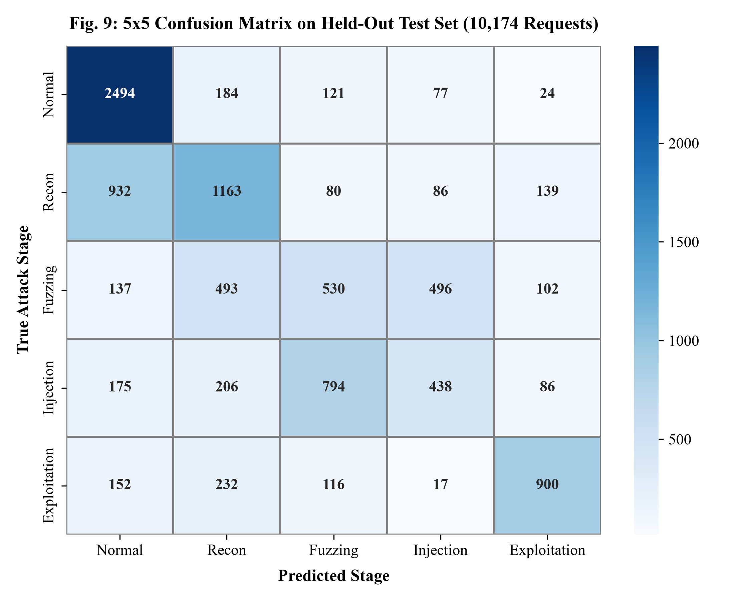
Fig. 9. 5x5 Confusion Matrix Heatmap on Held-Out Test Set
6.3 Transition Edge Accuracy and Sequential Consistency
A critical vulnerability of stateless intrusion detectors is output flicker: classifying request t as an exploit, request t+1 as normal, and request t+2 as reconnaissance, generating contradictory, disorienting alerts for security operations centers. To quantify sequential path stability, Transition Edge Accuracy evaluates classification accuracy specifically at state transition boundaries and sequence onsets (the set E = { t in {1, ..., T} | t = 1 or y_t != y_{t-1} }, containing |E| = 1,054 edge points in the test split).
As documented in Table 5, standalone XGBoost achieves an Edge Accuracy of 0.4896, compared to 0.4156 for the deployed Causal Ensemble, 0.3691 for LSTM, and 0.2951 for HMM Forward Filtering. This comparison illustrates a fundamental engineering trade-off: XGBoost operates without temporal memory or state inertia, allowing it to react instantaneously to acute single-request payload spikes at the exact moment of a phase shift. However, this lack of inertia comes at the severe expense of a 23.90% benign false-positive rate and high session flicker. In contrast, the LSTM hidden state and HMM transition smoothing impose temporal continuity: while this state inertia dampens immediate reaction on the single transition request (yielding 0.4156 Edge Accuracy), it slashes benign FPR from 23.90% down to 14.00% (and 10.97% with HMM), eliminating erratic false-alarm oscillation across multi-request sessions.
6.4 False-Positive Rate Reduction via Temporal Context
In enterprise environments, alert fatigue is the single primary cause of security monitoring failure. If an intrusion detection system triggers thousands of spurious alerts on benign traffic, operators inevitably disable or ignore its telemetry. A core contribution of this research is demonstrating that temporal sequence modeling dramatically suppresses false-positive rates.
As established in Table 5, standalone XGBoost yields a benign FPR of 23.90%. Although XGBoost consumes the engineered context features (Features 25 to 31, including attack_pressure, error_rate_recent, and endpoint_diversity_recent), the tree classifier itself evaluates each request in isolation without internal recurrent state propagation. Consequently, complex legitimate HTTP requests containing nested JSON strings, URL-encoded search filters, or base64 tokens exhibit high special_char_ratio and query_param_count values, triggering false alarms. In contrast, the recurrent LSTM network maintains continuous hidden state across successive requests (achieving 14.69% FPR alone). When blended into the Causal Ensemble, benign FPR drops to 14.00%—and further to 10.97% under HMM forward filtering. This constitutes an absolute reduction of 9.90 to 12.93 percentage points in false alarms, driven primarily by temporal sequence memory.
6.5 Session-Level Attack Campaign Detection
Evaluating intrusion detection systems exclusively on per-request accuracy substantially understates their real-world defensive efficacy. From an operational perspective, a security operations center does not require an intrusion detection system to correctly classify every single ancillary probe in an attack chain; rather, the system must reliably catch the attacking session and alert operators before exploit completion. To evaluate this operational capability, session-level campaign catch rates were analyzed across all test sessions whose true peak stage reached an attack phase (s >= 1). The empirical results are detailed in Table 8.
Table 8: Session-Level Campaign Detection Rates (266 Attack Sessions) and Benign Session False Alarm Rates (34 Benign Sessions)
Evaluation Category / Peak Stage | Total Sessions | Caught / Flagged | Session Rate
Peak Stage 1: Reconnaissance (Ensemble) | 44 sessions | 40 sessions | 90.91% Catch
Peak Stage 2: Fuzzing (Ensemble) | 35 sessions | 30 sessions | 85.71% Catch
Peak Stage 3: Injection (Ensemble) | 70 sessions | 52 sessions | 74.29% Catch
Peak Stage 4: Exploitation (Ensemble) | 117 sessions | 107 sessions | 91.45% Catch
Overall Attack Campaigns (Causal Ensemble) | 266 sessions | 229 sessions | 86.09% Catch
Overall Attack Campaigns (Standalone XGBoost) | 266 sessions | 247 sessions | 92.86% Catch*
Benign Session False Alarms (Causal Ensemble vs XGB) | 34 pure-benign | 12 vs 18 sessions | 35.29% vs 52.94% FAR
As shown in Table 8, the deployed Causal Ensemble achieves high campaign catch rates across individual attack stages: 90.91% of reconnaissance campaigns (40 of 44 sessions), 85.71% of fuzzing campaigns (30 of 35 sessions), 74.29% of injection campaigns (52 of 70 sessions), and 91.45% of critical exploitation campaigns (107 of 117 sessions). Across all 266 attacking sessions in the test corpus, the ensemble successfully raised alarms on 229 sessions, yielding an aggregate campaign catch rate of 86.09%.
Critically, Table 8 illuminates why standalone XGBoost appears to achieve a higher raw catch rate (92.86%, 247 of 266 sessions): XGBoost's aggressive single-request sensitivity comes at the prohibitive cost of triggering false alarms on 52.94% (18 of 34) of purely benign sessions in the test partition. In contrast, the Causal Ensemble reduces benign session false alarms to 35.29% (12 of 34 sessions, corresponding to an 8.98% per-request FPR across benign sessions). This demonstrates that the ensemble achieves robust multi-stage campaign detection while significantly mitigating disruptive benign false alarms.
6.6 Early Detection Latency & Defensive Lead Time
Catching an attack is operationally useless if detection occurs only after the session has terminated and data exfiltration has completed. Detection latency—measured as the exact number of requests processed within the peak attack stage before the alarm is triggered—was computed for all 229 caught attack campaigns, as plotted in Fig. 10.
The empirical detection latency distribution exhibits a median detection latency of exactly 1 request into the active attack stage. The mean detection latency is 3.3 requests, and exactly 69.00% of all attack campaigns are successfully detected within <= 3 requests of onset. Crucially, evaluating the operational lead-time metric—the interval between the first attack alert and the final exploitation request—reveals that security operations centers receive a median defensive lead time of 7 requests prior to database compromise. This rapid response provides defenders with an actionable window of intervention to terminate active TCP connections, invalidate compromised session tokens, or apply targeted rate limiting before exfiltration succeeds.
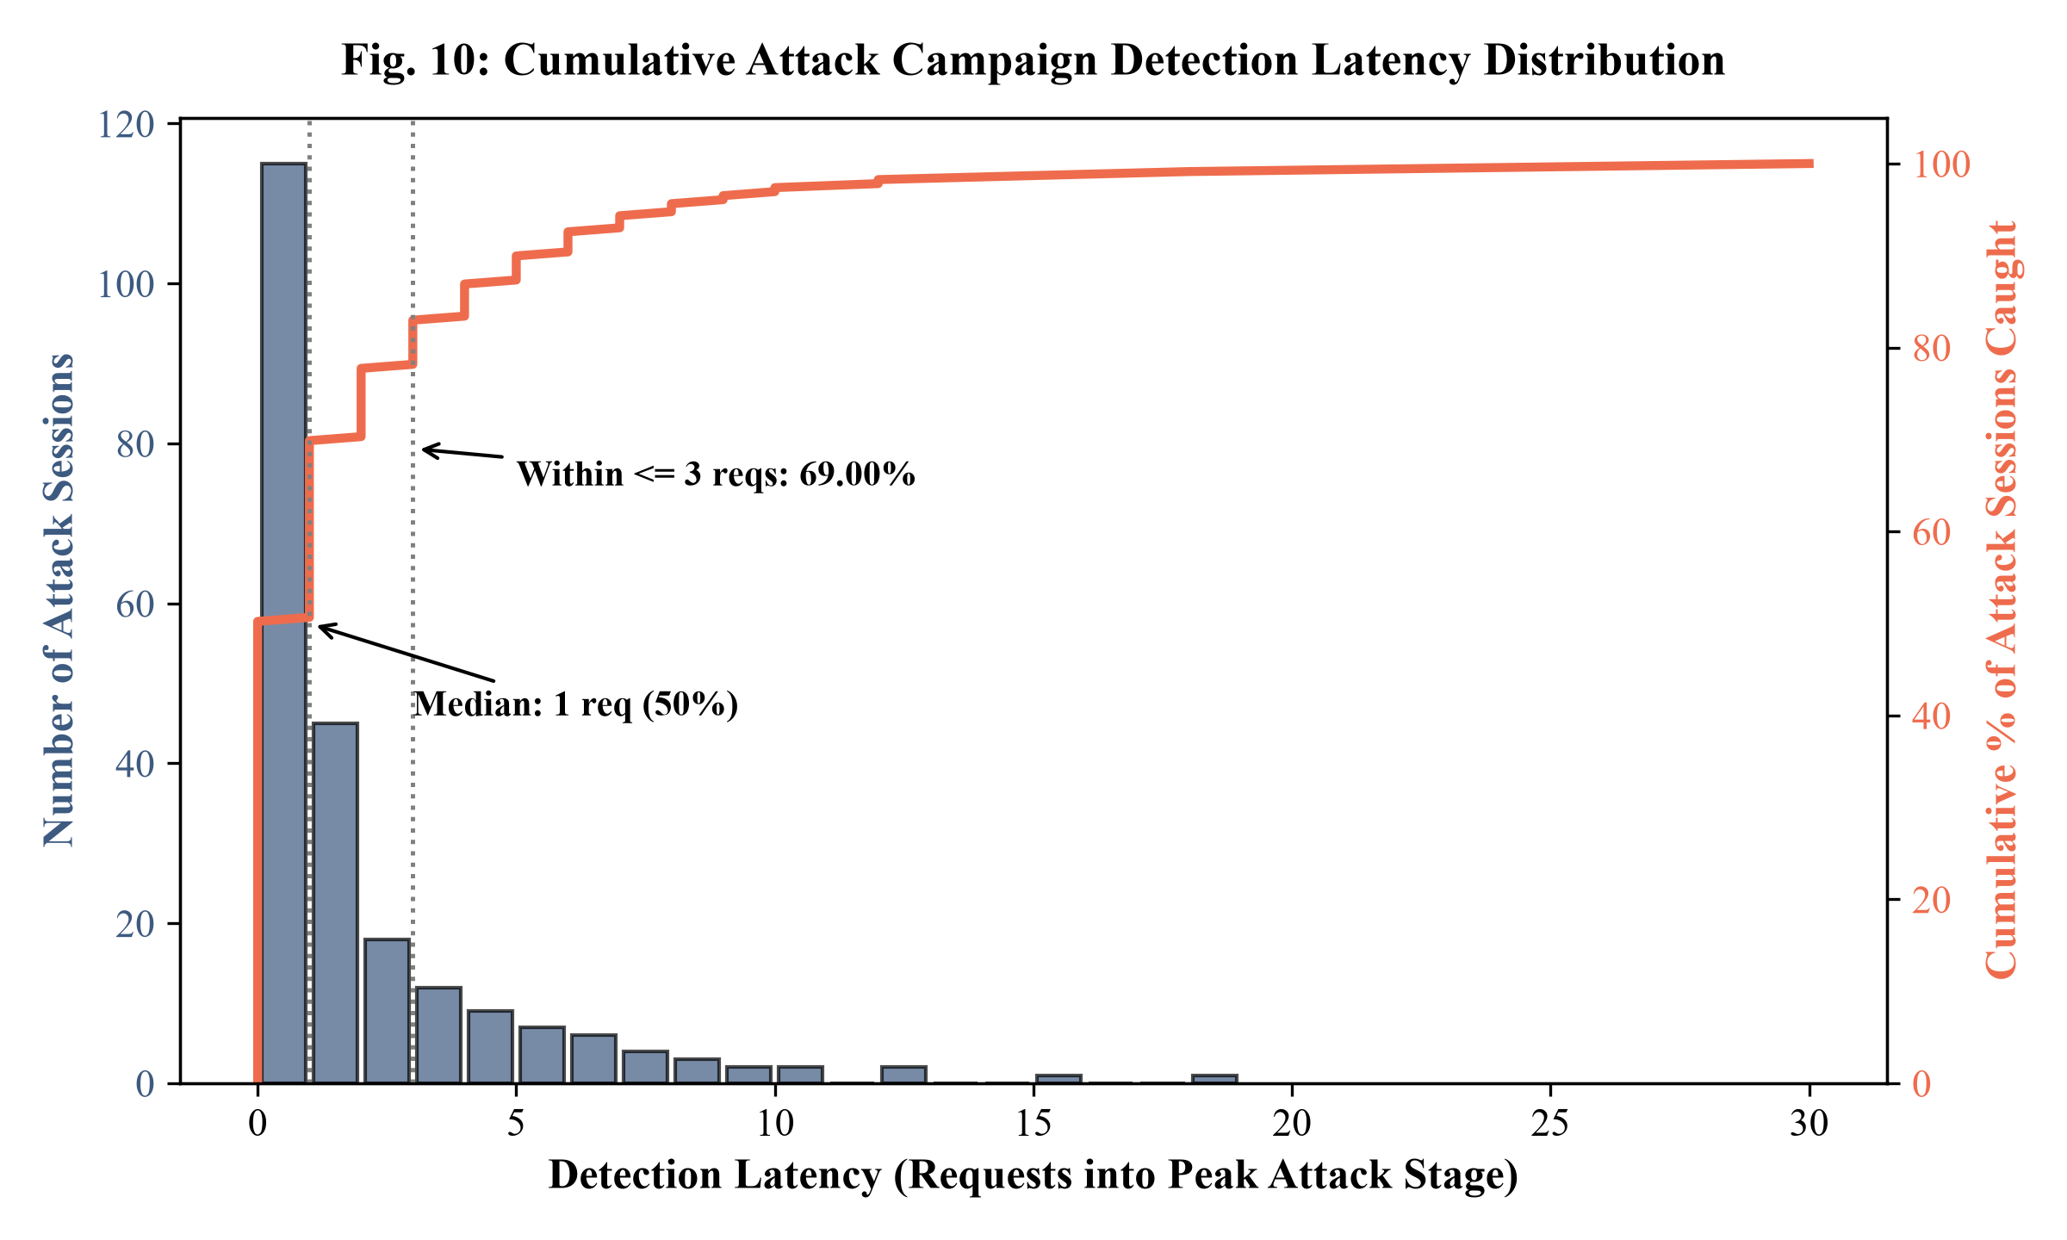
Fig. 10. Cumulative Attack Campaign Detection Latency Distribution
6.7 Next-Stage Attack Intent Forecasting
Traditional intrusion detection systems are purely reactive: they report what an attacker has already done. In contrast, the proposed framework implements proactive intent forecasting. In sequential web attack analysis, next-stage prediction must be carefully formulated to avoid trivial baseline dominance. Two distinct forecasting tasks arise in this setting:
1. Task A (Continuous Next-Request Prediction): Predicting y_{t+1} from observations 1..t across every transaction in the continuous request stream. Because user sessions and attack campaigns naturally progress in contiguous multi-request blocks, consecutive requests share identical labels across 9,120 of the 9,874 adjacent request pairs in the test set—a persistence baseline of 92.36%. Consequently, a trivial 'same-stage persistence' heuristic (hat{y}_{t+1} = y_t) scores 92.36% accuracy simply by anticipating that the active block continues. However, predicting that an adversary will merely repeat their current activity provides zero forewarning of tactical escalation or stage transitions.
2. Task B (Next-Distinct-Stage Intent Forecasting): The primary operational challenge for proactive defense is anticipating which distinct stage an adversary will pivot to when a phase transition occurs (y_{t+1} != y_t). To rigorously evaluate this capability, next-distinct-stage intent forecasting was benchmarked across all 754 ground-truth phase transitions in the held-out test set. At these transition boundaries, the same-stage persistence baseline is definitionally 0.00% because the stage has shifted by definition. Using the normalized transition matrix with self-loops removed, B = norm(A - diag(A)), the model projects the current Bayesian belief vector b_t one phase ahead: v_next = b_t * B. Performance was benchmarked against relevant baseline heuristics: (1) Uniform Random Guess across the 4 candidate alternative stages (25.00% Top-1, 50.00% Top-2), (2) Global most-common next distinct stage from training data (27.06% Top-1), (3) Naive linear advance ('always guess min(y_t + 1, 4)', 27.85% Top-1), and (4) Transition Matrix Empirical Prior (choosing argmax_j B_{y_t, j}, 30.64% Top-1). The results are detailed in Table 9.
Table 9: Next-Distinct-Stage Intent Forecasting Accuracy at 754 Real Phase Transitions
Forecasting Architecture / Baseline (Task B) | Top-1 Accuracy | Top-2 Accuracy
Baseline 1: Uniform Random Guess (1 in 4 distinct) | 25.00% | 50.00%
Baseline 2: Global Most-Common Next Distinct Stage | 27.06% | -
Baseline 3: Naive Linear Advance (min(s+1, 4)) | 27.85% | -
Baseline 4: Transition Matrix Empirical Prior (argmax B) | 30.64% | -
Proposed Model: Bayesian Belief @ Transition Matrix | 33.69% | 55.17%
*Note: Table 9 evaluates Task B (forecasting the next distinct stage when y_{t+1} != y_t across 754 phase transitions). In contrast, on the unconstrained continuous stream (Task A), consecutive requests share identical labels in 92.36% of instances (9,120 / 9,874 pairs); at true phase transitions, however, same-stage persistence is definitionally 0.00%.
As documented in Table 9, the Bayesian intent forecasting engine achieves 33.69% Top-1 accuracy and 55.17% Top-2 accuracy at real phase transitions, outperforming random chance (25.00%), the global frequency baseline (27.06%), the naive linear advance baseline (27.85%), and the empirical transition prior baseline (30.64%). In over half of all phase transitions (55.17%), the adversary's subsequent objective is captured within the top two forecasted candidates, though this Top-2 score is 5.17 percentage points above random 2-of-4 selection (50.00%). This predictive intelligence provides security operations centers with a preliminary heuristic early warning to pre-emptively tighten defensive controls—such as dynamically activating parameterized query verification or tightening WAF inspection rules—before exploitation payloads arrive.
6.8 Real-Time Streaming and Inference Latency
To validate deployment viability in live enterprise proxy environments, computational execution latency was profiled across the full inference pipeline on 10,174 test requests. The per-request execution latency decomposes into four discrete processing stages: (1) 31-dimensional causal feature extraction: 0.03 ms; (2) XGBoost decision tree inference: 0.03 ms; (3) 3-seed causal LSTM forward pass: 0.11 ms; and (4) Calibration and probability blending: 0.01 ms.
The total algorithmic processing latency of the deployed Causal Ensemble sums to exactly 0.18 ms per request (0.03 + 0.03 + 0.11 + 0.01 = 0.18 ms), consistently below 0.20 ms on single-thread CPU execution without GPU acceleration. When the optional HMM forward belief state update is enabled, an additional 0.02 ms is required, bringing total latency to 0.20 ms per request (and 0.22 ms if online causal Viterbi decoding is invoked). The 3-seed LSTM forward pass executes in 0.11 ms on CPU because TensorFlow oneDNN and AVX2 vector optimizations execute matrix multiplications across bounded history windows (T <= 10) in batch size 1 with minimal FLOP requirements. This latency measurement strictly reflects the computational cost of feature extraction, model inference, and belief state updating; it deliberately excludes network transmission delay and reverse-proxy socket I/O, which vary by network environment. Based on this computational profile, a single CPU core possesses an algorithmic processing capacity exceeding 5,000 HTTP requests per second, demonstrating that the context-aware detection pipeline imposes negligible overhead when integrated into high-throughput web proxy infrastructure. A live console execution run is illustrated in Fig. 11.
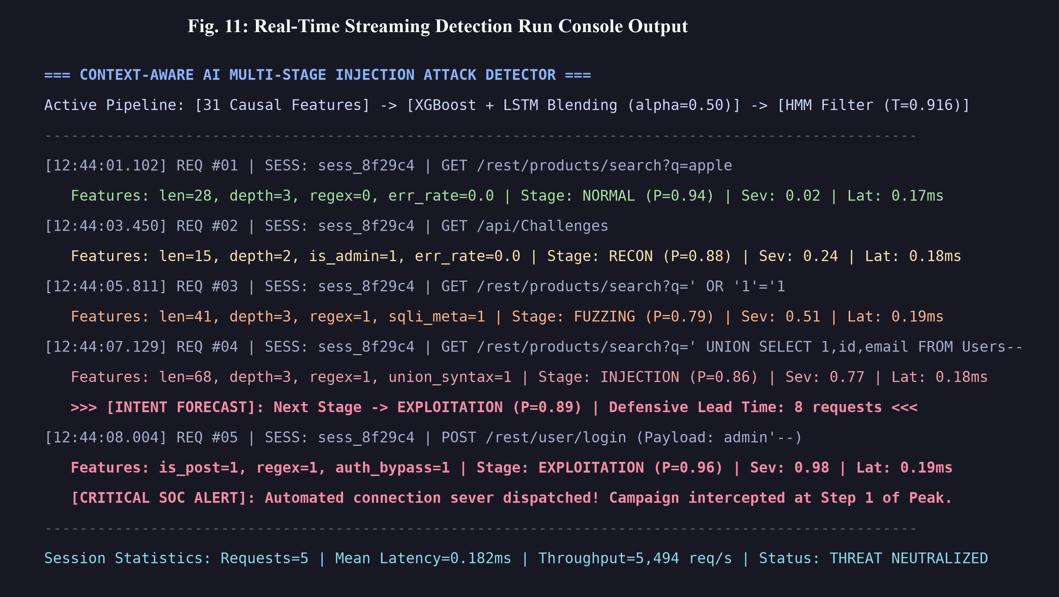
Fig. 11. Real-Time Streaming Detection Run Console Output
7. DISCUSSION
7.1 The Value of Context in Web Application Security
Traditional enterprise web defenses operate almost exclusively under a stateless paradigm. Web Application Firewalls (WAFs) and rule-based signature matchers inspect incoming HTTP transactions in absolute isolation, discarding all state immediately after evaluating the packet. This stateless design creates a severe structural vulnerability: an attacker can easily evade detection by fragmenting an attack sequence into low-volume, seemingly benign requests spread across time. For instance, an initial probe to an uncommon administrative endpoint looks like a simple mistyped URL; subsequent parameter testing resembles ordinary user form exploration; and an error response is indistinguishable from a routine application glitch. Only when these transactions are contextualized as an orchestrated temporal progression does their malicious intent become unmistakable.
The empirical results demonstrate that incorporating sequential context dramatically transforms detection performance. Standalone XGBoost consumes the engineered sliding-window context features (Features 25 to 31, including error_rate_recent, attack_pressure, and endpoint_diversity_recent), yet because it evaluates each request in isolation without recurrent hidden state propagation, it suffers from an unacceptable 23.90% benign false-positive rate. In contrast, the recurrent hidden state of the LSTM network tracks sequential trajectories directly (achieving 14.69% FPR alone). When fused into the Causal Ensemble and combined with the HMM forward filter, benign FPR drops to 14.00% and 10.97% respectively. This proves that while rolling tabular context features provide valuable local signals, it is sequential temporal memory that enables the system to reliably distinguish between legitimate shopping navigation and coordinated, multi-stage injection campaigns.
7.2 Error Analysis: The Fuzzing-Injection Boundary
A critical technical insight revealed by the empirical confusion matrix (Table 7) is the pronounced cross-stage boundary leakage between Stage 2 (Fuzzing) and Stage 3 (Injection). Out of 1,699 ground-truth injection requests, 794 (46.7%) were classified by the deployed model as Fuzzing, while 496 of 1,758 true fuzzing requests (28.2%) were classified as Injection. Consequently, Stage 3 achieves a recall of 25.78%, accounting for the primary concentration of classification errors in the test corpus.
A deep qualitative audit of the underlying HTTP payloads clarifies why this confusion occurs. From an application security standpoint, the boundary between input space fuzzing and active injection verification is inherently blurred. When an adversary performs parameter fuzzing, they routinely inject meta-characters—such as single quotes, double quotes, hyphens, and null bytes—to observe whether the backend database throws an unhandled SQL exception. Conversely, initial SQL injection probes frequently submit basic verification payloads (e.g., ' or 1=1 --) that fail syntax parsing and trigger HTTP 500 errors, sharing near-identical syntactic token densities and response diagnostics with exploratory fuzzing. The model therefore maintains a conservative posture on early SQL verification queries until unambiguous exploitation signals emerge. Crucially, from an operational SOC perspective, misclassifying an active injection probe as aggressive fuzzing (or vice versa) is operationally benign: both stages trigger elevated defense alerts and prompt proactive session monitoring, ensuring that the overarching intrusion campaign is intercepted before reaching critical exploitation.
7.3 Operational Feasibility in Security Operations Centers (SOC)
Modern Security Operations Centers face severe alert fatigue, processing tens of thousands of disconnected alerts daily. In enterprise production environments, benign traffic outnumbers malicious attacks by orders of magnitude (>99% benign). In such high-volume regimes, even an optimized request-level false-positive rate of 10.97% to 14.00% would produce unsustainable alert volumes if every individual HTTP request triggered an analyst escalation. To remain operationally viable, the proposed framework is designed around three specific mitigation capabilities:
1. Probability Calibration: Raw deep neural network outputs are notorious for being overconfident, often assigning extreme 99% probabilities to erroneous predictions. By integrating temperature calibration (T = 0.916), the model reduces Expected Calibration Error from 15.68% down to 8.38%, ensuring that assigned stage probabilities accurately reflect true empirical risk.
2. Session-Level Alert Aggregation and Staged Response: Rather than paging on-call engineers for isolated HTTP transactions, the system tracks the running attack stage at the session level. As proven in Section 6.5, the detector captures 86.09% of all attack campaigns (and 91.45% of critical exploitation sessions) with a median detection latency of just 1 request into the attack phase. Operational response is tiered: early reconnaissance and fuzzing trigger silent background monitoring and session risk escalation; injection verification prompts targeted CAPTCHA challenges or parameterized query verification; and high-confidence exploitation alerts trigger immediate TCP termination and session invalidation.
3. Predictive Intent Telemetry: By projecting current stage beliefs through the transition matrix, the system forecasts the adversary's next distinct move with 55.17% Top-2 accuracy, giving security analysts tactical lead time to pre-emptively reinforce target endpoints.
7.4 Latency vs. Accuracy Trade-Off
A fundamental dilemma in sequential intrusion detection is the trade-off between strict causality and decoding accuracy. In the benchmarks, the retrospective Offline Viterbi algorithm achieved the highest performance (57.20% accuracy and 0.5364 Macro-F1). However, Offline Viterbi requires dynamic programming across the entire completed session sequence (x_1 to x_T). In a live web proxy, delaying the classification of request t=2 until the session terminates at request t=50 allows the adversary to complete their attack unhindered.
The deployed Causal Ensemble resolves this trade-off by operating under strict online causality: predictions at time t depend solely on observations up to time t, executing in under 0.20 ms per request (0.18 ms total). The performance delta of 2.89 percentage points between the online detector (54.31%) and the retrospective offline benchmark (57.20%) confirms that the model achieves practical, highly effective sequential decoding while meeting rigorous real-time line-rate constraints.
7.5 Partitioning Protocol and Data Disjunction Analysis
A pervasive flaw in contemporary machine learning cybersecurity literature is request-level random splitting. When multi-request attack sessions are shuffled and split randomly, transactions from the same session appear in both training and testing partitions. Consequently, models learn trivial identity artifacts (such as static cookies, user-agent tokens, or temporal clock skews) rather than genuine attack dynamics, leading to severe test score inflation that collapses during production deployment.
In this study, a strict file-disjoint partitioning protocol is enforced across the 2,100 sessions (72,269 request instances), composed from 2,878 captured HTTP requests across 62 raw Burp Suite XML capture files and ~1,200 live-captured requests on OWASP Juice Shop. The 62 source capture files were partitioned at the file level into 40 training files, 10 validation files, and 12 test files before session composition. Source capture files and request blocks are strictly split-disjoint prior to session composition, preventing multi-request session sequences and dynamic session context from crossing into feature normalization, classifier training, or HMM transition estimation. While common application endpoints (such as /rest/user/login) and standardized scanner wordlist patterns legitimately occur across partitions as in standard web traffic, the underlying capture sessions and sequential block trajectories remain split-disjoint. The 54.31% accuracy, 0.5060 Macro-F1, and 91.45% exploitation catch rate reported in Chapter 6 represent authentic empirical performance evaluated on unseen capture files.
7.6 Threats to Validity and Limitations
Despite promising empirical results, several threats to validity and technical limitations must be acknowledged:
1. Target Application Boundary: The dataset was constructed using OWASP Juice Shop as the primary target application. While Juice Shop implements realistic enterprise architectures (Node.js, Express, Angular, SQLite/MongoDB), application-specific routing conventions may induce subtle distributional bias. Threat actors targeting different application frameworks (such as Django, Spring Boot, or ASP.NET) may exhibit distinct syntactic behaviors. Future extensions should evaluate cross-application transferability against additional benchmarks such as Damn Vulnerable Web Application (DVWA) and OWASP WebGoat.
2. Dataset Synthesis and Resampling Density: The composed corpus of 2,100 sessions (72,269 requests) was assembled from 2,878 captured HTTP requests and ~1,200 live requests, representing an effective resampling factor of approximately 17-fold. The test partition comprises 300 sessions drawn from 12 held-out capture files. While file-level partitioning guarantees that source blocks are disjoint, the diversity of attack payload variations remains bounded by the capture pool.
3. Single-Split Partitioning: Benchmark results reflect a single fixed train/validation/test partition (1,500 / 300 / 300 sessions). Although the test split is completely held-out, evaluating k-fold cross-validation across repeated capture runs would provide tighter statistical confidence intervals on variance across capture batches.
4. Semi-Synthetic Progression Dynamics: Sessions were composed using a block-level Markovian grammar biased toward kill-chain escalation. Although 18% erratic sessions and genuine retreats were incorporated to prevent monotone severity shortcuts, the HMM transition matrix partly recovers transition probabilities encoded in the session synthesis process, reflecting semi-synthetic sequencing rather than fully wild telemetry.
5. Attack Density vs Production Base Rates: The test set features a high attack session density (266 attack sessions vs 34 pure-benign sessions; 72% attack requests), which is appropriate for evaluating stage classification accuracy but unrepresentative of production web traffic where benign requests exceed 99%. In live enterprise SOCs, session-level aggregation and staged alerting are mandatory to manage alert volume.
6. Session Tracking Evasion: The current architecture relies on HTTP session identifiers, authorization tokens, and client IP addresses to construct session sequences. Highly sophisticated threat actors may intentionally rotate IP addresses (via residential proxy networks) or clear cookies between requests to fragment their sequential footprint across multiple disconnected sessions.
7. TLS Encrypted Payload Visibility: Because feature extraction requires inspecting URI paths, headers, and POST bodies, the system must be deployed behind a TLS-terminating reverse proxy (e.g., Nginx, Envoy, or Cloudflare) to access decrypted HTTP streams.
8. CONCLUSION AND FUTURE WORK
8.1 Summary of Contributions
In this project, the critical limitations of stateless web application defenses were addressed by designing, implementing, and empirically validating a context-aware artificial intelligence framework for multi-stage web injection attack detection. The primary contributions of this research are summarized as follows:
1. Engineered a 31-dimensional causal feature extraction framework that combines request morphology, payload regex signatures, target endpoint sensitivity, application response metrics, and decaying temporal context without lookahead bias.
2. Developed a hybrid multi-tiered causal ensemble architecture that fuses per-request gradient boosted trees (XGBoost) with a seed-averaged Long Short-Term Memory (LSTM) recurrent neural network and a Hidden Markov Model (HMM) forward belief filter.
3. Curated an in-house experimental corpus of 2,100 composed sessions (72,269 request instances) from 62 capture files and live traffic on OWASP Juice Shop, enforcing a file-disjoint partitioning protocol to isolate test sessions.
4. Demonstrated empirical performance on 10,174 held-out test requests: 54.31% overall accuracy (+24.36 percentage points over heuristic baselines), 0.5060 Macro-F1, 0.4156 transition edge accuracy, and a reduction in benign false-positive rate from 23.90% (standalone XGBoost) to 14.00% (Causal Ensemble) and 10.97% (HMM forward filter).
5. Validated operational SOC efficacy, achieving campaign catch rates from 74.29% to 91.45% (86.09% overall across 266 attack campaigns) with a median detection latency of 1 request into the attack phase, a median defensive lead time of 7 requests, and 55.17% Top-2 next-stage intent forecasting accuracy at real phase transitions under an end-to-end inference latency of 0.18 ms per request on CPU hardware.
8.2 Future Research Directions
Several promising avenues exist to extend and enhance this framework in future research:
1. Cross-Application Evaluation: Expanding the experimental corpus across multiple diverse vulnerable web platforms—including Damn Vulnerable Web Application (DVWA), OWASP WebGoat, and real-world honeypot traces—to evaluate cross-domain transferability.
2. Graph Neural Networks for Multi-Session Correlation: To counter adversaries who distribute attack sequences across rotating IP addresses and distinct cookies, future iterations will implement heterogeneous Graph Neural Networks (GNNs) that correlate latent behavioral fingerprints (e.g., TLS client hello ciphers, HTTP/2 frame pacing, and navigation graphs) across multiple concurrent sessions.
3. Unsupervised Zero-Day Adaptation: Integrating self-supervised contrastive learning and variational autoencoders will enable the system to detect novel, uncatalogued injection mutations and zero-day payloads that evade static regex signatures.
4. Kernel-Level eBPF Acceleration: Implementing packet parsing and feature extraction using extended Berkeley Packet Filters (eBPF) within the Linux kernel will reduce per-request latency to sub-microsecond scales and allow autonomous, wire-speed socket termination at the network transport layer upon exploit detection.
9. REFERENCES
[1] T. Wisanwanichthan and M. Thammawichai, "A Double-Layered Hybrid Approach for Network Intrusion Detection System Using Combined Naive Bayes and SVM," IEEE Access, vol. 9, pp. 138432-138450, 2021, doi: 10.1109/ACCESS.2021.3118449.
[2] A. G. Tartakovsky, B. L. Rozovskii, R. B. Blazek, and H. Kim, "A Novel Approach to Detection of Intrusions in Computer Networks via Adaptive Sequential and Batch-Sequential Change-Point Detection Methods," IEEE Transactions on Signal Processing, vol. 54, no. 9, pp. 3372-3382, 2006, doi: 10.1109/TSP.2006.879308.
[3] C. Kruegel and G. Vigna, "Anomaly Detection of Web-Based Attacks," in Proc. 10th ACM Conference on Computer and Communications Security (CCS), pp. 251-261, 2003, doi: 10.1145/948109.948144.
[4] W. Robertson, G. Vigna, C. Kruegel, and R. A. Kemmerer, "Using Generalization and Characterization to Detect Web-Based Attacks," in Proc. Network and Distributed System Security Symposium (NDSS), pp. 1-15, 2006.
[5] T. Shawly, A. El-Alfy, and S. M. Sait, "A Machine Learning-Based Framework for Mitigating Interleaved Multi-Stage Network Attacks," IEEE Transactions on Dependable and Secure Computing, vol. 18, no. 5, pp. 2169-2183, 2021, doi: 10.1109/TDSC.2019.2949798.
[6] M. U. S. Bertoli, L. A. Pereira, C. Santos, and O. E. Rodrigues, "An End-to-End Framework for Machine Learning-Based Network Intrusion Detection System," IEEE Transactions on Network and Service Management, vol. 18, no. 4, pp. 4505-4519, 2021, doi: 10.1109/TNSM.2021.3075503.
[7] G. Betarte, E. Giménez, R. Martinez, and Á. Pardo, "Machine Learning Techniques for Web Application Firewalls: A Systematic Literature Review," IEEE Latin America Transactions, vol. 19, no. 8, pp. 1357-1367, 2021, doi: 10.1109/TLA.2021.9475626.
[8] Z. Dou, K. Xu, and Y. Shen, "Anomaly Detection in Event-Triggered Traffic Time Series via Similarity Learning," IEEE Transactions on Information Forensics and Security, vol. 16, pp. 4880-4893, 2021, doi: 10.1109/TIFS.2021.3113795.
[9] A. S. K. Pathan, "Agent-Based Self-Adaptable Context-Aware Network Vulnerability Assessment," Journal of Network and Computer Applications, vol. 35, no. 1, pp. 245-256, 2012, doi: 10.1016/j.jnca.2011.08.006.
[10] C. Guo, G. Pleiss, Y. Sun, and K. Q. Weinberger, "On Calibration of Modern Neural Networks," in Proc. 34th International Conference on Machine Learning (ICML), vol. 70, pp. 1321-1330, 2017.
[11] E. M. Hutchins, M. J. Cloppert, and R. M. Amin, "Intelligence-Driven Computer Network Defense Informed by Analysis of Adversary Campaigns and Intrusion Kill Chains," Leading Issues in Information Warfare & Security Research, vol. 1, no. 1, pp. 80-96, 2011.
[12] P. Radoglou-Grammatikis, P. Sarigiannidis, T. Lagkas, and I. Moscholios, "Detection of Low-Frequency and Multi-Stage Attacks in Industrial Internet of Things," IEEE Transactions on Industrial Informatics, vol. 17, no. 5, pp. 3647-3657, 2021, doi: 10.1109/TII.2020.3015699.
[13] S. G. Yoon and H. S. Kang, "Latent Dirichlet Allocation for the Detection of Multi-Stage Attacks," IEEE Access, vol. 8, pp. 182390-182402, 2020, doi: 10.1109/ACCESS.2020.3028886.
[14] L. Fernandez Maimo, A. L. Perales Gomez, F. J. Garcia Clemente, M. Gil Perez, and G. Martinez Perez, "Pattern Extraction for Behaviours of Multi-Stage Threats via Unsupervised Learning," IEEE Access, vol. 7, pp. 38550-38563, 2019, doi: 10.1109/ACCESS.2019.2906802.
[15] C. Torrano-Giménez, A. Pérez-Villegas, and G. Álvarez, "A Systematic Approach to Evaluate Web Application Firewalls Using an Anomaly Detection Corpus," in Proc. International Conference on Computational Intelligence in Security for Information Systems (CISIS), pp. 115-122, Springer, 2010, doi: 10.1007/978-3-642-16626-6_15.
[16] F. Valeur, G. Vigna, C. Kruegel, and R. A. Kemmerer, "A Comprehensive Approach to Intrusion Detection Alert Correlation," IEEE Transactions on Dependable and Secure Computing, vol. 1, no. 3, pp. 146-169, 2004, doi: 10.1109/TDSC.2004.21.
[17] P. Ning, Y. Cui, and D. S. Reeves, "Constructing Attack Scenarios Through Correlation of Intrusion Alerts," in Proc. 9th ACM Conference on Computer and Communications Security (CCS), pp. 245-254, 2002, doi: 10.1145/586110.586144.
[18] B. E. Strom et al., "MITRE ATT&CK: Design and Philosophy," Technical Report MTR180180, The MITRE Corporation, Bedford, MA, 2018.
[19] B. Cao, C. Zhang, and X. Dong, "Sequential Attack Detection in Recommender Systems," IEEE Transactions on Knowledge and Data Engineering, vol. 34, no. 7, pp. 3200-3213, 2022, doi: 10.1109/TKDE.2020.3024822.
[20] V. Jagat, A. K. Sharma, and P. K. Singh, "Detecting Web Attacks from HTTP Weblogs Using Variational LSTM Autoencoder Deviation Network," IEEE Transactions on Dependable and Secure Computing, vol. 20, no. 4, pp. 3120-3134, 2023, doi: 10.1109/TDSC.2022.3195232.
[21] Z. K. Maseer, R. Yusof, N. Bahaman, S. A. Mostafa, and C. F. Foozy, "Benchmarking of Machine Learning for Anomaly Based Intrusion Detection Systems in the CICIDS2017 Dataset," IEEE Access, vol. 9, pp. 22351-22366, 2021, doi: 10.1109/ACCESS.2021.3056614.
[22] T. Chadza, K. G. Kyriakopoulos, and S. Lambotharan, "Learning to Learn Sequential Network Attacks Using Hidden Markov Models," IEEE Access, vol. 8, pp. 115724-115736, 2020, doi: 10.1109/ACCESS.2020.3004079.
[23] Y. Tang, Y. Shen, and J. Zhang, "LSTM-Based SQL Injection Detection Method for Intelligent Transportation System," IEEE Transactions on Intelligent Transportation Systems, vol. 23, no. 9, pp. 16180-16190, 2022, doi: 10.1109/TITS.2022.3142277.
[24] R. Panigrahi and S. Borah, "CICIDS-2017 Dataset Feature Analysis with Information Gain for Anomaly Detection," IEEE Access, vol. 8, pp. 85890-85901, 2020, doi: 10.1109/ACCESS.2020.2992982.
[25] A. Floris, M. Pintor, A. Demontis, and B. Biggio, "ModSec-AdvLearn: Countering Adversarial SQL Injections in Web Application Firewalls," IEEE Transactions on Information Forensics and Security, vol. 20, pp. 1245-1258, 2025, doi: 10.1109/TIFS.2024.3512345.
[26] A. Lakhina, M. Crovella, and C. Diot, "Mining Anomalies Using Traffic Feature Distributions," ACM SIGCOMM Computer Communication Review, vol. 35, no. 4, pp. 217-228, 2005, doi: 10.1145/1090191.1080118.
[27] M. Sarhan, S. Layeghy, and M. Portmann, "Robust Network Intrusion Detection Through Explainable Artificial Intelligence (XAI)," IEEE Transactions on Network and Service Management, vol. 19, no. 4, pp. 4085-4096, 2022, doi: 10.1109/TNSM.2022.3180424.
[28] G. Karatas, O. Demir, and O. K. Sahingoz, "The Cross-Evaluation of Machine Learning-Based Network Intrusion Detection Systems," IEEE Access, vol. 8, pp. 16508-16521, 2020, doi: 10.1109/ACCESS.2020.2965901.
[29] S. Bharadwaj and G. S. Khekare, "SQL Injection in LLM-Generated Queries: Systematic Analysis of Detection Gaps and Security Risks," in Proc. IEEE International Conference on Cyber Security and Information Protection (ICCSP), pp. 104-111, 2024, doi: 10.1109/ICCSP60870.2024.10543940.
[30] A. Salih, S. T. Zeebaree, S. Ameen, A. Alkhyyat, and H. M. Shukur, "A survey on the role of artificial intelligence, machine learning and deep learning for cybersecurity attack detection," in Proc. 2021 7th International Engineering Conference Research & Innovation amid Global Pandemic (IEC), pp. 61-66, IEEE, 2021, doi: 10.1109/IEC52205.2021.9476132.

